Bioeconomic model for cost minimization in the production of Gilthead Seabream (Sparus Aurata)

Carmelo León¹, Juan María Hernández² and Eucario Gasca-Leyva³

¹ Department of Applied Economic Analysis, Univ. of Las Palmas de G.C. 35017 Las Palmas de G.C. Spain. E-mail: carmelo@empresariales.ulpgc.es

² Department of Quantitative Methods for Economics and Management, University of Las Palmas de G.C. 35017 Las Palmas de G.C. Spain. E-mail: juanh@empresariales.ulpgc.es

³ Centre of Research and Advanced Studies of the IPN. Mérida, México. E-mail: Eucario@kin.cieamer.conacyt.mx.

Abstract

A bioeconomic model was designed for gilthead seabream (Sparus aurata). The biological side of the model is according with fish physiology and based in preliminary works applied to other species (Muller-Feuga 1990). Based on simulations, the usual properties of the implicit production function were studied. The model was also utilized for analyzing optmization decision in the industry relative to ration size and harvesting time. Two different contexts were considered, a restricted biological setting and an expanded economic problem. It was shown that the optimal ration size increases for the latter context, reaching values commonly accepted in current industrial practice. This optimal ration size was rather robust on changes in input prices and interest rates.

Keywords: cost-minimization, elasticity of substitution, gilthead seabream, ration size, harvesting time.

1 Introduction

The aquaculture industry has experienced a continuous process of growth in last decades. Market share out of total seafood production has increased from 14.4% in 1989 to 23% in 1995, and it is considered one of the food production industries with largest growth rates in the world (FAO 1997). Part of this growth is explained by the appearance of new species which have become successful for commercial culture. Economic models have been developed in parallel with the expansion of the industry (Allen and Johnston 1976, Shang 1981, and Allen et al. 1984). Examples of bioeconomic models for particular species can be found in Bjorndal (1990), Sparre (1977), Leung and Shang (1989), Cacho et al. (1990), and Rizzo and Spagnolo (1996) for salmon, trout, prawn, catfish, and European seabass respectively. By modeling the complex interactions between the economic and biological systems, it is possible to obtain the most efficient decisions about aspects such as diet composition, feeding rates, and harvesting time. However, since biological and external conditions affecting growth are specific to each organism, bioeconomic models cannot be applied across species. Thus, further research is needed in modeling other species with prospects of future development.

In this paper we present a simple bioeconomic model for gilthead seabream (Sparus aurata), which is one of the most important species in the Mediterranean basin (Stephanis 1996). This model includes a growth model which allows us to explain physical growth in terms of temperature, ration size, and fish weight. The purpose of the bioeconomic model is to analyze cost minimization decisions by the aquaculture firm producing seabream. Cacho, Hatch and Kinnucan (1990) studied the rates of substitution between dietary inputs with catfish data. In the case of seabream, data limitations preclude the inclusion of the protein content as a primary input to the production process. However, we consider harvesting time as a decision variable which is endogenously related to all other inputs utilized in the farm, but in a simplified optimization setting applied to gilthead seabream.

The objective is to derive the trade-offs farmers face between harvesting time and feeding rates in the production of seabream. The feeding rate is modeled with the concept of a percentage ration size, which enables us to abstract from the complex interactions within the biological model. In the practice of seabream ranching, farmers tend to utilize a constant rule of thumb in feeding which is maintained through the harvesting time according to recommendations from feed suppliers. There is also a common practice of overfeeding when production is undertaken in off-shore cages with the advantages of natural recirculation. Thus, the approach provided by a static optimization model can be useful to represent seabream feeding in off-shore cages, abstracting from the dynamic implications which can be only considered in more general models.

A step forward in the analysis of optimization decisions at farm level involves the study of the general characteristics of the production function describing the relationships between inputs and output in the production process. Past models focusing on other species have not directly addressed the properties of the implicit production function derived from the biological model in the aquaculture firm. These properties are relevant for the optimization problem to have a unique solution at each point of time, and provide evidence from an empirical point of view about the technological frontier facing the individual firm. Thus, we attempt to study the production technology for seabream, obtaining the elasticity of substitution between primary inputs and the conditional elasticities of scale. It is shown that the production function is quasi-concave and defines convex isoquants, and the elasticity of substitution decreases with the ration size.

The implicit production function describes the technology the aquaculture firm faces according to biological restrictions. This function is used to derive the cost function, which is inserted in the cost minimization problem to be solved for the efficient decisions about the ration size and harvesting time. In order to simplify the problem we assume that harvest weight is given by market conditions and consumer preferences. The results show that optimal decisions about the ration size approach observed managerial practices. This optimal decision involves a trade-off between biological and economic inputs. The model also allows us to obtain short run predictions on the optimal input combinations from price changes, deriving values for input elasticities.

In the following sections we outline the bioeconomic model, including the biological part and the cost minimization problem. This will be followed by the results on the characterization of the implicit production function and the analysis of the optimal management of ration size and harvesting time in a static setting. The final section contains a summary of the main conclusions and implications for firm management decision making.

2 The bioeconomic model

2.1 The biological submodel

Fish growth can be influenced by several factors, including fish weight, water temperature, feeding rate, water quality, diet quality, stocking rates and environmental conditions. The complex interactions among these factors and data limitations imply the need of making assumptions based on available evidence. Relevant data has been obtained in cage systems placed in the Canary Islands waters, which provide some environmental advantages in comparison with other sites. Thus, we assume that water quality is optimal. Water recirculation is not a problem due to the Golfstream branch going through the Canary Islands. On the other hand, cages are located away from sewage pollution problems. Therefore, dissolved oxygen and nitrogen-ammonia do not reach levels constraining fish growth.

Second, we consider there are no stocking density problems, since this was not observed in cage management. That is, under common managerial operations fingerlings are allowed to grow in a given density until they reach commercial size, but no complete investigation has been reported on the effects on varying density levels in cages. Thus, we assume density levels have been optimally adjusted to cage capacity. Finally, in respect of feed quality we have assumed this is also given, due to the lack of sufficient evidence on the optimal diet levels and composition effects. Nevertheless, these assumptions do not invalidate the workings of the model against real data.

Let us consider a growth model similar to Stauffer (1973), initially formulated for salmons. Stauffer's model describes growth according to physiology, and has been applied successfully to other species (Corey et al. 1983, Muller-Feuga 1990). Fish growth is determined by fish weight (w), water temperature (θ) and the ration size (r). The total effect is separable into three factors. The general model follows the equation:
$(1) \frac{\text{dw}}{\text{dt}}={Γf}_{1}(w)f_{2}(ϑ)f_{1}(r)\text{.}$
where f₁(w) represents the weight function, f₂(θ) is the thermal function, and f₃(r) is the ration function. Parameter Γ is exogenous and incorporates the rest of factors influencing growth and not considered explicitly.

$(2) f_{1}(w)=w^{m}\text{.}$The weight function is assumed to be loglinear. That is,

The increase in weight is positively determined by fish weight, but at a decreasing rate. Therefore, parameter m must take values less than one (m<1). This specification has been shown to represent the growth process for most organisms. For instance, m has been estimated for hot blood vertebrates, taking a value of 0.7. In the case of fish species, it has been observed several relationships between weight and metabolism, making m to vary between 0.65 and 0.85 (Brett 1979).

$(3) f_{2}\left(ϑ\right)=D\left(e^{α(ϑ_{M}−ϑ)}−e^{β(ϑ_{M}−ϑ)}\right),$Function f₂(θ) for temperature is based on the Arrhénius law. It is assumed that fish growth is feasible in a range of temperature values. A suitable expression for this function can be the following one,

where θ is a stepwise function of monthly uniform random variables, θ(t)∼Unif(μ_{t}^{ai},μ_{t}^{bi}), t ∈ (t_{i},t_{i+1}), i ∈ {1,2,...}, μ_{t}^{ai} and μ_{t}^{bi} are respectively the minimum and maximum temperature in each month i. Parameter θ_{M} is the maximum temperature for which there is positive growth. This is defined as the lethal temperature for 50% of individuals in 92 hours. Parameters D, α, and β are determined by statistical estimation.

Regarding the ration function, we consider a normalized form to model the influence of the ration size on fish growth. The common approach to model the ration function specifies some asymptotic exponential function (Stauffer 1973, Corey et al. 1983, Cacho 1990). This approach requires substantial data on the relationship with temperature and fish size, increasing the number of parameters and assumptions in the model. However, we can get around this problem by considering a percentage ration size r, which is the ratio between the daily feeding weight and the daily maximum feeding weight. That is
$(4) r=\frac{\frac{\text{dR}}{\text{dt}}}{\frac{{\text{dR}}_{M}}{\text{dt}}} \text{.}$

where R is the accumulated feeding weight given to fish and R_{M} is the maximum feeding weight, i.e. the one giving largest growth rate.

Farmers are assumed to manage feeding rates according to a percentage of the maximum feeding weight. Since this percentage is independent of fish weight and temperature, modelization becomes simple and results easy to interpret. The relationship between the ration size and fish growth follows directly from fish physiology.

$(5) Z(r)=\frac{\frac{\text{dw}}{\text{dt}}}{\frac{{\text{dw}}_{M}}{\text{dt}}} \text{.}$In order to represent the ration function f₃(r), there is need to introduce a normalized growth rate, Z(r), and a normalized conversion rate, Y(r). The normalized growth rate is defined as the quotient between the growth rate and growth rate for the maximum ration in the same period, (dw_{M}/dt), that is:
$(6) Y(r)=\frac{r}{Z(r)} \text{.}$On the other hand, the normalized conversion rate is defined as the quotient between the ration size and the normalized growth rate. Thus,

$(7) f_{3}(r)=\frac{Z(r)}{Z(r_{c})}\text{.}$This equation provides a relationship between the normalized fish growth and the ration size. Hence, the effects of changes in the ration size on fish growth can be modeled by the normalized growth rate defined in relation to the normalized culture ration. Therefore, function f₃(r) can be specified as

$(8) Y(r)=r\left(1+\frac{c(1−r)^{2}}{r_{m}(1−r_{m})^{2}(r−r_{m})}\right)\text{.}$The normalized conversion rate has to reflect the expected patterns with respect to the ration size. That is, it should decrease between the starvation and the optimal ration, approach asymptotically the maintenance ration size, reach a minimum at the optimal ration, and take the value of one for the maximum rate. The following expression does represent these theoretical properties for the normalized conversion rate:

It can be seen that this function depends on two parameters which are specific for each fish species, i.e. the maintenance ration, r_{m}, and the optimal ration r_{o}.

2.2 The cost optimization problem

The biological model suggests that there are a number of exogenous and endogenous factors which can have an influence on fish growth. It is clear that farmers make economic decisions by controlling some of these factors, such as the ration size (r) and the harvesting time (t_{h}). Thus, there is need to derive the optimal managerial decisions, as those which would minimize the total costs of production.

Total feed consumed is derived from the ration size by calculating the conversion rate given fish growth, as shown in Appendix A. In order to concentrate on the analysis of the ration size, we first consider a partial minimization problem involving the total costs of feeding, assuming that the rest of input decisions are optimally determined. Then, we will consider the more general problem where feeding decisions are traded against other input decisions.

Therefore, farmers could face a first simple problem consisting of finding out both the ration size and the harvesting time that minimize total feed costs for a given harvest size. This problem can be formulated as:
$\begin{aligned}(9) \text{Min} C_{f}(r,t_{h}) \\ s\text{.}t\text{.} W(r,t_{h})=W_{F},\end{aligned}$
where C_{f}(r,t_{h}) is the total feed costs of growing a fish stock until harvesting time t_{h} using r ration size. W(r,t_{h}) is the fish weight function which follows by managing the farm according to t_{h} and r. Feeding costs are minimized subject to the restriction that the final weight of each individual to be equal to the desired weight W_{F}. In order to simplify the problem, we assume that all fries are stocked at the same date t₀=0 and harvested after time t_{h}. In addition, we have assumed stocking costs are set to zero.

$(\text{10}) C_{f}(r,t_{h})=p_{f}\text{ΓΝ}\int{\text{CR}(w,θ,r)f_{1}(w)f_{2}(θ})f_{3}(r)e^{−\text{it}}\text{dt},$In order to calculate feed costs, a function that relates feed consumption to weight gain is needed. Total feed consumption is obtained by integrating daily feed consumption over the crop length. Thus, it follows that

$(\text{11}) W(r,t_{h})=W_{0}+Γ\int{f_{1}(w)f_{2}(θ})f_{3}(r)\text{dt},$where CR(w,θ,r) is the conversion rate function, i.e. the ratio of feed consumption over weight gain, p_{f} indicates the feed price per unit, and i is the interest rate. N is the number of fingerlings determined by farm capacity, which is assumed to be 200 ton. per year. The number of individuals tends to decrease during the production cycle due to mortality. The fish weight function can be retrieved from

where W₀ is the initial weight. The fact that the conversion rate depends on fish weight and random temperature, and considering the specific expressions for f₂(θ) and f₃(r), make it difficult to generate an analytical solution to problem (9). However, it can be seen that if the conversion rate were constant over time, then the problem solution would be trivial. This would be given by the ration size that minimizes the normalized conversion rate, i.e. r_{o}=0.5. In practice, the problem solution should account for the influence of fish weight and temperature on the conversion rate.

$(\text{12}) C_{T}(r,t_{h})=C_{F}+C_{V}(r,t_{h}),$A more general optimization problem follows from considering the influence of other costs in feeding decisions. Thus, we can extend problem (9) by augmenting for the total costs of farm ranching. Therefore, let the total cost function be:

where in the short run we distinguish between total fixed costs C_{F} and total variable costs C_{V}. The former incorporates all the necessary infrastructure such as cages, boats, nets and machinery, and its amount is defined by the production capacity of the farm. The latter depends on the costs of feeding by a ration size r, the total harvesting time t_{h}, the labor employed, the number of fingerlings as determined by farm capacity and the interest rate.

$(\text{13}) C_{V}(r,t_{h})=C_{L}(t_{h})+C_{m}(t_{h})+C_{S}(r,t_{h})+C_{f}(r,t_{h})+C_{C}(r,t_{h},L)+C_{O}(r,t_{h}),$Considering the most relevant factors involved in fish farm production, total variable costs can be expanded as follows:

where C_{L} refers to the labor cost, C_{m} is the technical management cost, C_{S} is the sanitary cost, C_{C} is workers commission to production, and C_{O} includes other costs. Since costs are defined for each individual, they must be multiplied by the number of fish in order to derive the total variable cost. The formulae for the cost components of total variable costs are as follows:
$\begin{aligned}(\text{14}) C_{L}(t_{h})=p_{L}\int{{\text{Le}}^{−\text{it}}}\text{dt}, \\ C_{m}(t_{h})=c_{m}\int{e^{−\text{it}}}\text{dt}, \\ C_{m}(r,t_{h})=c_{s}\text{ΓΝ}\int{f_{1}(w)f_{2}(θ)f_{3}(r)e^{−\text{it}}}\text{dt}, \\ C_{f}(r,t_{h})=p_{f}\text{ΓΝ}\int{\text{CR}(w,θ,r)f_{1}(w)f_{2}(θ)f_{3}(r)e^{−\text{it}}}\text{dt}, \\ C_{C}(r,t_{h})=c_{c}L\text{ΓΝ}\int{f_{1}(w)f_{2}(θ)f_{3}(r)e^{−\text{it}}}\text{dt}, \\ C_{O}(r,t_{h})=c_{o}\text{ΓΝ}\int{f_{1}(w)f_{2}(θ)f_{3}(r)e^{−\text{it}}}\text{dt},\end{aligned}$
where p_{L} stands for the cost of labor per day, c_{m} refers to the technical management cost per day; c_{s}, c_{c} and c_{o} are respectively the cost of sanitary treatments, the cost of workers commission and other costs as defined per day and per individual gram gained of weight. L is the number of workers determined by farm capacity. This means 10 workers and an initial number of 550.000 individuals (Stephanis 1995). In the short run, the firm chooses the optimal input combination that minimizes total costs, i.e.
$\begin{aligned}(\text{15}) \text{Min} C_{T}(r,t_{h}) \\ s\text{.}t\text{.} W(r,t_{h})=W_{F}\text{.}\end{aligned}$
In this formulation, total costs become dependent on the ration size and the harvesting time, making it comparable to the more restricted problem (9). In fact, the restricted problem can be considered as a formulation focusing on the biological part of production, whereas the general short run problem emphasizes the potential substitutability of the rest of production inputs in managing ration sizes.

3 Results

The bioeconomic models for cage farm ranching were developed using a system dynamics approach (Forrester 1961). This is a general methodology commonly utilized for building up and simulating dynamical models. An specific software (POWERSIM 2.05) was employed for implementing the model in a computer. From a numerical point of view, an Euler integration method with a time step of 1-day was adopted.

The growth model was tested against data from fish growth in cages, using some of the validation tests recommended for system dynamics models (Sterman 1984, Barlas 1989). In this respect, Appendix B shows that the theoretical model did provide a satisfactory representation of the data. Unexplained behavior might be due to misspecification errors in the thermal parameters, which have been taken from evidence on other species.

3.1 Input substitution and conditional returns

The growth model proposed for seabream serves as the basis for the production function describing the state of technology in cage farm ranching. Since the production function determines the limits of economic efficiency, it might be convenient to analyze its economic properties. Moreover, the conditions for economic optimization depend on general properties of the technology as represented by the growth model, such as quasiconcavity. Thus, by scrutinizing these properties it is possible to derive important conclusions as to the degree of substitutability between primary inputs and the extent of scale economies at plant level. Figure 1 represents the technological map in a two input space, where we consider harvesting time as an input to be combined with the ration size in order to produce a given level of harvest weight. Isoquants represent the combinations of both inputs which are capable of producing a product of a given weight. Increasing the final weight would imply utilization of more quantities of at least one of the inputs. The technological map shows that isoquants are convex towards the origin and present a fair degree of substitution between inputs. For instance, in order to produce a 350 grams (g.) fish there is a potential choice ranging from a 100 percent ration size in 350 days production to a 25 percent ration size in a cycle of 1200 days.

Marginal rates of substitution for several final weight levels are presented in Table 1. Convex isoquants imply decreasing marginal rates of substitution as defined by the derivative of the ration size with respect to harvesting time. For a given harvest weight (W_{F}), as farmers increase the ration size, the amount of harvesting time to be given up becomes smaller. Thus, once farmers determine the product size there is scope for substitution between the primary inputs to the fish growth process. For instance, assuming a 500 g. fish weight and 50% ration size, one point rise in the ration size would allow farmers a reduction in 8.1 harvest days.

For a given ration size, cage growth technology shows that the marginal rate of substitution increases as farmers raise harvest weight. That is, since the ratio of marginal products between primary inputs increases with harvest size, harvesting time becomes relatively less productive. This proves that the production function cannot be written as quasilinear, i.e. marginal rates of substitution are not constant along a parallel line to any of the axes.

For a given harvest weight, it can be shown that productivity depends on ration size. Figure 2 depicts the marginal and average products which are derived by assuming both one year and year and a half harvesting time. The marginal product curve reaches a maximum for a 30% ration size, below the maximum average product around 50% ration size. Thus, as ration size increases, farmers are expected to obtain decreasing marginal and average products, as expected by the law of diminishing returns. These are short run results, in the sense that harvesting time and the rest of factors are considered fixed in the analysis. It can be seen that the marginal product tends to zero as ration size approaches 100%. This means that further increases in ration size would add negatively to fish growth.

Maximum average product as shown in Figure 2 represents the highest production efficiency level to be derived from technology. For a competitive firm this would be the technical optimum determining the lowest bound in its supply curve. However, economic efficiency follows only by considering the costs involved in production. That is, the optimizing management decision results from putting the efficient production locus given by the growth model against the costs of production.

Harvest size might have effects on production efficiency, thereby conditioning input choice by farmers. From results in Table 1 and looking at Figure 1, it can be seen that if we consider a given input combination of harvesting time and ration size, the marginal rate of substitution becomes smaller as harvest weight rises. That is, the marginal rate of substitution is not constant along a given ray from the origin, revealing that the implicit production function is not homothetic. Therefore, the production function can not be written as an increasing monotonic transformation of a homogenous function. Moreover, since the marginal rate of substitution is decreasing, a decision to produce larger product sizes across proportional input combinations would imply a reduction in the marginal product of ration size in relation to the marginal product of harvesting time.

The final weight might be affected by proportional changes in the amount of primary inputs. In this respect, a conditional returns to scale elasticity can be considered in order to appraise the potential impact of harvesting time and ration size on output. This is defined as the final fish weight increase when both primary inputs (harvesting time and ration size) do change by the same proportion. This can be expressed as ((ΔW_{F}/W_{F})/(k-1)), where ΔW_{F} represents the increase in the final harvest weight and k is the proportionality factor. Results for the computed elasticities of scale are shown in Table 2, revealing increasing returns to scale for ration sizes below 90%. That is, the elasticity of scale is larger than one for any considered isoquant level or harvest size. This means that if farmers raise both primary inputs by the same factor, given the rest of inputs in the farm, then harvest weight will increase more than proportionally.

3.2 Optimal primary inputs

The short run optimal combination of primary inputs would be obtained by cost minimization as formulated in problems (9) for the restricted case and (15) for the more general case. That is, given a harvest weight, farmers would choose the most efficient combination of harvesting time and ration size, as defined by those input levels where costs reach a minimum. In the restricted case, only feeding costs are minimized, while in the general setting total costs are considered. In Figure 3 we have represented isocost maps for both problems, i.e. those input combinations generating a given cost level in the cost function for the restricted biological problem and for the general economic problem. It can be seen that isocosts are not linear for these problems. This is due to the dynamic nature of the implicit production function, and from the fact that harvesting time does not have an explicit market price. Harvesting time can be considered as an essential input determining the total costs of the rest of inputs in the production process. Further, comparing the restricted problem with the general problem, isocosts curves become less sloped for the latter, due to the increase in the relative opportunity cost of time when other inputs are considered in the production process.

The cost minimizing solution is obtained by the tangency condition between the lowest isocost curve and the isoquant determining the final weight. Table 3 presents the results for different objective harvest weights formulated by the aquaculture firm. The desired harvest weight chosen by the firm might be influenced by market conditions, in the sense that consumer preferences could favor specific market sizes. Results show that the optimal ration size varies significantly for the conditioned problem, from 40% for a 350 g. final weight, to 62% for the largest weight of 700 g. In fact, these results for cost minimization when only feeding costs are considered seem to be according with the suggestions for optimal biological management as formulated in the literature (Brett 1979). The optimal conversion rate follows from a ration size of 50%, since this is the feeding strategy which would maximize fish growth relative to the total feed consumed.

However, the cost function should allow for other costs which might affect the optimal feeding decision. Table 3 also presents the optimal ration size and harvesting time for short run cost minimization in the general economic problem. It can be seen that the optimal solution for the ration size varies significantly less than in the strictly biological problem, ranging from 75% for a 600 g. fish weight to 85% for a 350 g. final weight. Moreover, these results show larger optimal ration sizes for the general economic problem, which are in the range of those recommended for industrial practices. Thus, as the rest of inputs are controlled in the production process, farmers tend to substitute harvesting time for ration size. This is due to the fact that harvesting time becomes more expensive as other inputs such as labor and sanitary treatments are considered in the analysis.

Under the assumption of cost minimization, we can consider the effects of a marginal change in the ration price on the optimal ration size. That is, farmers can be interested in the scope for substitution among ration size and harvesting time when facing a change in input prices. In this respect, the elasticity of substitution allows us to evaluate the sensitivity of the optimal input combination to factor prices. Since the ration size is determined by fish growth, there is not an explicit price for this input, which has been calculated as the marginal change in costs when there is a unit change in the ration size. Thus, the elasticity of substitution has been evaluated for implicit price changes of the input combination of ration size and harvesting time. This is defined as
$(\text{16}) σ=\frac{\frac{Δ({t_{h}}/r)}{({t_{h}}/r)}}{\frac{Δ(∂{t_{h}}/∂r)}{(∂{t_{h}}/∂r)}} \text{.}$
That is, the elasticity of substitution is the ratio of the proportionate change in factor proportions (t_{h}/r) to the proportionate change in the marginal rate of substitution (∂t_{h}/∂r). Under cost minimization, the marginal rate of substitution is equal to relative shadow factor prices as defined by the ratio between the ration size and harvesting time marginal costs, i.e. (∂C/∂r)/(∂C/∂t_{h}).

Table 4 shows the results computed along given isoquants. It can be seen that the impact of marginal changes in feeding prices is larger if the chosen option involves relatively more time intensive processes. That is, as the optimal technical combination becomes less time intensive by increasing the ration size, the elasticity of substitution becomes smaller. The implication is that marginal changes in shadow input prices show substantially smaller effects for the general economic problem than for the restricted biological problem. In the former, the elasticity of substitution ranges between 0.18 and 0.22, while in the latter, input substitution is represented by an elasticity varying between 0.44 and 0.82. These results suggest that for lower efficient ration sizes, the impact of marginal changes in shadow prices on the ration size is larger than for relatively optimal higher ration sizes.

However, both the optimal combination and the total costs of fish production might be sensitive to the input prices which are influencing the shadow prices for ration size and harvesting time. Table 5 shows the price sensitivity results for the optimal input combination. The optimal ration size is not significantly affected by 10% changes in factor prices of labor, feed, and management. This result follows from the relatively lower elasticity of substitution to be found at the optimal ration size. Similarly, changes in the interest rate do not have a significant effect on the optimal ration size, as shown in Table 6. That is, given the harvest weight, feeding decisions and harvesting time are invariant to the interest rate.

Total costs are positively related with both the input prices and the final size. This follows from the fact that larger sizes involve more production time. Figure 4 illustrates that total costs are rather sensitive to marginal input prices, and Table 7 presents the cost elasticities for input prices at the optimal input combination. Since the elasticities are not constant along the price-cost curves, they have been calculated as the average effect of an equal rise and fall in prices. Depending on harvest size, total cost elasticities are in the range of 0.29-0.38 for the price of labor, 0.18-0.21 for the price of feed, 0.08-0.14 for the management price. Therefore, these results suggest that total costs are most sensitive to the price of labor and less sensitive to the unit management costs. The interest rate presents the lowest impact on total costs. The effect of an increase in the interest rate is negative because discounted costs become lower.

4 Conclusions

Bioeconomic models are useful to represent firm behavior in aquaculture. However, these models require substantial amount of information on the biology of fish species, and this might not be readily available for species which have not been thoroughly investigated in an experimental setting. Nevertheless, economic modeling is becoming increasingly demanded as the industry develops with the introduction of new culture species. In this paper, we have considered a cost minimization model for gilthead seabream, which is one of the species with a great potential for market development in the Mediterranean. This model is based on a simplified growth model, which has been tested to work satisfactorily against observed data.

It is assumed that the growth process is determined by the ration size, water temperature and fish weight. The relationship between fish growth and the ration size is modeled by defining a conversion rate in normalized form. This normalization approach for the ration size does reduce the amount of information and assumptions needed to model fish growth. Thus, this formulation can be applied to new culture species with little empirical information, such as the Pagrus Pagrus, which is another sparidae species recently introduced in the Mediterranean market.

The growth model implicitly defines a production function for the aquaculture firm, which is shown to fail both homotheticity and quasilinearity. Thus, since the marginal rate of substitution is not constant along a given ray from the origin, the production function can not be written as a monotonically increasing transformation of a homogeneous function. This means that for a constant input ratio, the marginal rate of substitution between harvesting time and ration size depends on the final harvest weight. However, the production model allows for short run substitution between harvesting time and ration size, and returns to scale are increasing with respect to these inputs. In addition, the production function is quasiconcave, thus an optimization problem can lead to an interior solution for the most efficient input combination.

From the analysis of the implicit production function, it is clear that farmers face a technical trade-off between harvesting time and ration size. The efficient combination follows from rational behavior, i.e. by finding the input levels which minimize the costs incurred in production. Two possible problems have been considered. In the first problem, the firm minimizes only the costs of primary inputs, i.e. the feeding costs as traded against the shadow cost of harvesting time, assuming the rest of production costs are set at optimal levels. It is shown that the optimal choice for this problem leads to the optimal biological ration size, i.e. the one which minimizes the conversion rate. However, once the model allows for all the relevant economic costs involved in production, this is interpreted as an increase in the shadow cost of harvesting time, leading to a higher ration size, similar to the one observed in commercial practice. The optimal ration rate depends on fish weight, and turns out to be below the maximum rate.

The relevance of these results for farm decision making can be noted by the fact that suboptimal ration sizes lead to lower economic returns. Efficient management of ration size requires a cost minimization approach, which would contribute to optimal profits. The model is also relevant if we consider the extended practice of managing feeding rates according to a constant ration size. This management rule is convenient from an operational point of view. Further research should analyze the theoretical basis for this practice, which could be framed in a model of risk farm decision making. In general, a ration size above the optimal implies higher feed consumption which can have a negative impact on fish growth by reducing the levels of dissolved oxygen. Future extensions of the model will incorporate more precision in modeling fish biology, which would allow us to consider other aspects in managing fish production, such as the diet quality and the batching process. However, these extensions will only be possible as further results on the biology and culture of seabream become available.

References

Allen, P.G. and Johnston, W.E. (1976) Research direction and economic feasibility: An Example of Systems Analysis for Lobster Aquaculture. Aquaculture, 9, 155-180.

Allen, P.G. Botsford, L.W., Schuur, A.M. and Johnston, W.E. (1984) Bioeconomics of Aquaculture. Elseviere, Amsterdam.

Arnason, R. (1992) Optimal Feeding Schedules and Harvesting Time in Aquaculture. Marine Resource Economics, 7(1), 15-35.

Barlas, Y. (1989) Multiple Test for Validation of System Dynamics Type of Simulation Models. European Journal of Operational Research, 42, 59-87.

Bjorndal, T. (1988) Optimal Harvest Time in Fish Farming. Marine Resource Economics, 5(2), 139-159.

Bjorndal, T. (1990) The Economics of Salmon Aquaculture. Blackwell Scientific Publications. Oxford.

Brett, J.R. (1979) Environmental Factors and Growth. In: Fish Physiology, Vol. 8 (eds. W.S. Hoar, D.J. Randall and J.R. Brett), pp 599-667. Academic Press, London.

Cacho, O.J. (1990) Protein and Fat Dynamics in Fish. A Bioenergetic Model Applied to Aquaculture. Ecological Modelling, 50, 33-56.

Cacho, O.J., Hatch, U. and Kinnucan, H. (1990) Bioeconomic Analysis of Fish Growth. Effects of Dietary Protein and Ration Size. Aquaculture, 88, 223-238.

Chambers, R.G. (1988) Applied Production Analysis. Cambridge University Press. Cambridge.

Corey, P.D., Leith, D.A. and English, M.J. (1983) A Growth Model for Coho Salmon including Effects of Varying Ration Allowments and Temperature. Aquaculture, 30, 125-143.

FAO. (1997) The World State of Fishery and Aquaculture. Roma, Italy.

Forrester, J.W. (1961) Industrial Dynamics. Productivity Press.

Heaps, T. (1993) The Optimal Feeding of a Farmed Fish. Marine Resource Economics, 8(1), 89-99.

Leung, P. and Shang, Y. (1989) Modeling Prawn Production Management Systems: a Dynamic Markow Decision Approach. Agriculture Engineering, 5, 171-182.

Mistiaen, J.A. and Strand, I. (1999) Optimal Feeding and Harvest Time for Fish Weight-Dependent Prices. Marine Resource Economics 13, 231-246.

Muller-Feuga, A. (1990) Modélisation de la croissance des poissons en élevage. Rapports scientifiques et techniques de l'IFREMER. Institut Français de Recherche pour l'Exploitation de la Mer.

Oliva, R. (1996) Empirical Validation of a Dynamic Hypothesis. In: System Dynamics 96, System Dynamics Society, Vol. 2 (eds. G.P. Richardson and J.D. Sterman), pp 405-408.

Ravagnan, G. (1984) L'élevage du loup et de la daurade en valliculture. In: L'Aquaculture Du Bar Et Des Sparidés (eds. G. Barnab‚ et R. Billard), pp 435-446. INRA Publ., Paris

Rizzo, G. and Spagnolo, M. (1996) A Model for Optimal Management of Sea Bass Dicentrarchus Labrax Aquaculture. Marine Resource Economics, 11, 267-286.

Shang, Y.C. (1981) Aquaculture Economics: Basics Concepts and Methods of Analysis. Westview Press, Boulder, Colorado.

Sparre, P. (1977) A Markovian Decision Process Applied to Optimization of Production Planning in Fish Farming. Meddr Danm. Fisk.-og Havunders, 7, 111-197

Stephanis, J. (1995) Economic Viability of Production Systems Seabass/Seabream in Greece (Industrial Scale). CIHEAM Cahiers Options Méditerranéennes, 14, 65-77.

Stephanis, J. (1996) Mediterranean aquaculture industry trends in production, markets and marketing. CIHEAM Cahiers Options Méditerranéennes, 17, 93-102.

Sterman J.D. (1984) Appropiate Summary Statistics for Evaluating the Historic Fit for the System Dynamic Models. Dynamica, 10(2), 51-66.

Stauffer, G.D. (1973) A Growth Model for Salmonids Reared in Hatchery Environments. Thése Phd., Dep. of Zoology, Univ. Washington, Seattle, WA.

Theil, H. (1966) Applied Economic Forecasting. Amsterdam: North-Holland.

Appendix A

In order to fully specify the biological model, parameter values have been determined by empirical estimation and calibration. Table A.1 presents the description, values and sources of estimation for all the specific parameters. For the weight function, parameter m was estimated using monthly data on mean fish weight in six offshore floating cages in the period 1994-1996. A number of 198.080 individuals were stocked in different cages depending on their size.

The water temperature variation in the Canary Islands is relatively small with extreme values ranging from 18ºC to 23ºC. A regression analysis between weight and growth in loglinear form was carried out assuming various temperature intervals, showing that parameter m varies between 0.21 and 0.29 (Table A.2). Mean value 0.23 was considered for model specification.

For the thermal function, parameters α and β are taken from Muller-Feuga (1990), i.e. α=-0.12, β=-0.15. The value of the parameter θ_{M}=32.9ºC is taken according to Ravagnan (1984). Parameter D was introduced to calibrate function f₂(θ) with our data, obtaining a value of D=4.93. The parameters for the uniform distributions in the thermal function were set according to monthly extreme water temperature values in the Canary Islands.

Figure A.1 represents the effects of temperature on fish growth. Optimum water temperature for seabream is around 24ºC to 26ºC. Out of this range, there is a progressive decline in growth, with very low growth when temperature is below 12ºC and no growth above 32.9ºC.

In respect of function f₃(r), the actual values for the maintenance and optimal ration (r_{m} and r_{o}) vary across species. For simplicity, we have assumed a value of r_{m}=0.12, according to the most reported value in the literature. The optimal ration is defined as half the maximum growth ration, i.e. r_{o}=0.5. Parameter Γ is assumed to be one.

The growth model can be used to derive the feed needed for a fish to reach a specific size. In order to do this, it is necessary to transform the normalized conversion rate Y(r) into a conversion rate for different values of w, θ and r (CR(w,θ,r)). This function indicates the amount of feed consumed necessary for an unity of weight gain. The total amount of feed consumption is then obtained by summing up the feed consumed by a fish over a given harvesting time. Equation (6) leads to the following relationship:
$(A\text{.}1) Y(r)=\text{CR}(w,θ,r){\left[\frac{{{\text{dw}}_{M}}/{\text{dt}}}{{{\text{dR}}_{M}}/{\text{dt}}}\right]}_{w,ϑ} \text{.}$
$(A\text{.}2) \text{CR}(w,θ,r)={\text{Hw}}^{γ}\text{.}$Thus, the normalized conversion rate is equal to the product between the conversion rate and the quotient between the maximum fish growth (dw_{M}/dt) and the daily maximum growth ration for a given fish weight. Conversion rates have been obtained from data for different weights and temperature levels, assuming a maximum growth ration (r_{M}). This assumption reflects observed managerial practices in the culture farm where data were collected. Given a fixed temperature value (θ₀), these data provided a good fit to the following loglinear relationship:

Parameters H and γ were estimated statiscally for two groups of temperature intervals. Results are shown in Table A.3. Low values of correlation coefficient R² is due to a high dispersion in conversion rate estimations. The rest of conversion rates for other temperature intervals were calibrated according with these results and the influence of temperature in seabream growth.

In order to obtain conversion rates for ration sizes different from r_{M}, the quotient ((dw_{M}/dt)/(dR_{M}/dt))_{w,θ} is calculated from equation (A.1) using the conversion rate function estimated above. Consequently, the conversion rate can be derived for any ration size.

Appendix B

Figure B.1 represents the simulated and observed data for ten different samples of fish growing in six cages, covering a period of 30 months from June 1994 to December 1996. Some of the cages were used for two samples of fish stocked at different weights and time periods. Simulations start at the same stocking time and harvest weight for each of the samples.

Intuitively, it can be observed in Figure B.1 that simulations do closely reflect the observed data. Nevertheless, we have conducted appropriate statistical tests to validate the model, following Barlas (1989) and Oliva (1996).

Table B.1 presents the validation measures of the R², the Root Mean Square Error (RMSE) and the Theil's inequality coefficient for each sample. The samples with relatively large number of observations exhibit satisfactory values for these statistics. The Theil's inequality coefficient was calculated for the percentage changes in the observed and simulated data respectively. Results show values below 0.20, allowing us to affirm the model's reliability.

In order to analyze the sources of the total error, we have split the Mean Square Error in three components, as proposed by Theil (1966). Thus, low bias and variation components would indicate that errors are not systematic (Sterman 1984). In Table B.1, errors accumulate for the largest samples in the third component. However, the variation component is also relatively large. These results show that the model reproduces the observed data in their mean value, although the variance has not been very well adjusted. This might be due to a misspecification of the thermal parameters, taken from works about other species, as Muller-Feuga (1990).

Appendix C

$\begin{aligned} \text{Min} C_{f}(r,t_{h}) \\ s\text{.}t\text{.} W(r,t_{h})=W_{F},\end{aligned}$Giving the problem (9), i.e.

we can assure that the following necessary conditions for the existence of an unique solution are satisfied:

- Existence of at least a critical point (r*,t_{h}*) ∈ [0,1]x[0,+) in the Lagrangian function L(r,t_{h},λ)=C_{f}(r,t_{h})-λ(W(r,t_{h})-W_{F}).

- The restriction function W(r,t_{h}) is quasiconcave.

These conditions are proved as follows:

• Condition 1.

$\begin{aligned}(C\text{.}1) \frac{∂L}{∂r}=\frac{∂C_{f}}{∂r}−λ\frac{∂W}{∂r}=0 \\ \frac{∂L}{∂t_{h}}=\frac{∂C_{f}}{∂t_{h}}−λ\frac{∂W}{∂t_{h}}=0 \\ \frac{∂L}{∂λ}=−(W(r,t_{h})−W_{F})=0\text{.}\end{aligned}$The partial derivates of the Lagrangian function for problem (9) are

$(C\text{.}2) \frac{∂C_{f}}{∂r}−\frac{\frac{∂C_{f}}{∂t_{h}}}{\frac{∂W}{∂t_{h}}}\frac{∂W}{∂r}=0\text{.}$Thus, condition 1 is proved if we show the existence of (r*,t_{h}*) ∈ [0,1]x[0,+) verifying W(r*,t_{h}*)=W_{F} such that

Expanding the last equation by using (10) and (11),

$\begin{aligned}(C\text{.}3) \frac{∂C_{f}}{∂r}−\frac{\frac{∂C_{f}}{∂t_{h}}}{\frac{∂W}{∂t_{h}}}\frac{∂W}{∂r}=p_{f}Γ\int{\frac{∂\text{CR}(w,θ,r)}{∂r}f_{1}(w)f_{2}(θ)f_{3}(r)e^{−\text{it}}\text{dt}}+ \\ +p_{f}Γ\int{\text{CR}(w,θ,r)f_{1}(w)f_{2}(θ)\frac{∂f_{3}(r)}{∂r}e^{−\text{it}}\text{dt}}− \\ −\frac{p_{f}Γ\text{CR}(w(t_{h}),θ(t_{h}),r)f_{1}(w)f_{2}(θ)f_{3}(r)e^{−{\text{it}}_{h}}}{{Γf}_{1}(w)f_{2}(θ)f_{3}(r)}\int{{Γf}_{1}(w)f_{2}(θ)\frac{∂f_{3}(r)}{∂r}\text{dt}}= \\ =p_{f}Γalignl\begin{aligned}\left[\int{\frac{∂\text{CR}(w,θ,r)}{∂r}f_{1}(w)f_{2}(θ)f_{3}(r)e^{−\text{it}}\text{dt}}+\int{\text{CR}(w,θ,r)f_{1}(w)f_{2}(θ)\frac{∂f_{3}(r)}{∂r}e^{−\text{it}}\text{dt}}− | \right] \\ \end{aligned} \\ \end{aligned}$
$(C\text{.}4) \frac{∂f_{3}}{∂r}=\frac{1}{Y(r)Z(r_{c})}−\frac{∂Y/∂r}{Y(r)}f_{3}(r),$In order to simplify notation, let us denote g(w,θ)=((dw_{M}/dt)/(dR_{M}/dt))_{w,θ}. From equation (A.1) and

it follows that
$\begin{aligned}(C\text{.}5) \frac{∂C_{f}}{∂r}−\frac{\frac{∂C_{f}}{∂t_{h}}}{\frac{∂W}{∂t_{h}}}\frac{∂W}{∂r}= \\ =p_{f}Γ\left[\int{\frac{1}{g(w,θ)}f_{1}(w)f_{2}(θ)\frac{1}{Z(r_{c})}e^{−\text{it}}\text{dt}}−\text{CR}(w(t_{h}),θ(t_{h}),r)\int{f_{1}(w)f_{2}(θ)\frac{∂f_{3}}{∂r}e^{−\text{it}}\text{dt}}\right]\text{.}\end{aligned}$
$(C\text{.}6) \frac{∂f_{3}}{∂r}=\frac{1}{Y^{2}(r)Z(r_{c})}\frac{{\text{cr}}^{2}(1−r)(r−(2r_{m}−1))}{r_{m}(1−r_{m})^{2}(r−r_{m})},$
By expanding equation (C.4)

thus, we can determine the sign of the equation (C.5) for two different values of r:
$(C\text{.}7) \frac{∂C_{f}}{∂r}−\frac{\frac{∂C_{f}}{∂t_{h}}}{\frac{∂W}{∂t_{h}}}\frac{∂W}{∂r}=p_{f}Γ\left[\int{\frac{1}{g(w,θ)}f_{1}(w)f_{2}(θ)\frac{1}{Z(r_{c})}e^{−\text{it}}\text{dt}}−0\right]>0,$- If r=1, then (∂f₃/∂r = 0), so

for all θ ∈ [0,+).

$\begin{aligned}(C\text{.}8) {\text{lim}}_{r→r_{m}^{+}}\left(\frac{∂C_{f}}{∂r}−\frac{\frac{∂C_{f}}{∂t_{h}}}{\frac{∂W}{∂t_{h}}}\frac{∂W}{∂r}\right)= \\ p_{f}Γ\left[\int{\frac{1}{g(w,θ)}f_{1}(w)f_{2}(θ)\frac{1}{Z(r_{c})}e^{−\text{it}}\text{dt}}−{\text{lim}}_{r→r_{m}^{+}}\left(\text{CR}(w(t_{h}),θ(t_{h}),r)\int{f_{1}(w)f_{2}(θ)\frac{∂f_{3}}{∂r}e^{−\text{it}}\text{dt}}\right)\right]\text{.},\end{aligned}$- On the other hand

that diverges to - for all θ ∈ [0,+).

$(C\text{.}9) \frac{∂C_{f}}{∂r}(r^{}{\text{,t}}_{h}^{})−\frac{\frac{∂C_{f}}{∂t_{h}}(r^{}{\text{,t}}_{h}^{})}{\frac{∂W}{∂t_{h}}(r^{}{\text{,t}}_{h}^{})}\frac{∂W}{∂r}(r^{}{\text{,t}}_{h}^{})=0\text{.}$Therefore, by using a simple extension of Bolzano's theorem, and due to the existence of the implicit function t_{h}=ϕ^{W}_{F}(r) (see Condition 2), we can assure that ∃ (r*,t_{h}*) ∈ [0,1]x[0,+) verifying W(r*,t_{h}*)=W_{F} such that

In conclusion, we have shown the existence of at least a critical point for L(r,t_{h},λ).

• Condition 2.

In order to show that function W(r,t_{h}) is quasiconcave, we use the following lemmas:

$H_{α}=\left\{x∈M/f(x)≥α\right\}$Lemma 1 Let f: M ⊆ ℜ^{n} → ℜ be a function with M a convex set. Then, a necessary and sufficient condition for f to be a quasiconcave function is that

is a convex set, for all α ∈ ℜ.

Lemma 2 Let f: M=UxV ⊆ ℜ^{n} → ℜ be a C² function with M a convex set,
$H_{α}=\left\{x∈M/f(x)≥α\right\} \text{is} \text{convex}⇔ϕ \text{is} a \text{convex} \text{function}$U ⊆ ℜ^{n-1}, V ⊆ ℜ. Given α ∈ ℜ, assume that ∃ ϕ: U → V a biyective function such as f(x_{U},ϕ(x_{U}))=α, for all x_{U} ∈ U (true if ∂f/∂x_{V} ≠ 0, for all x_{V} ∈ V). Then

Both lemmas are proved using results from real classical analysis.

Then, from these lemmas, we can show that function W(r,t_{h}) is quasiconcave if the function t_{h}=ϕ^{W}_{F}(r) corresponding to isoquant W(r,t_{h})=W_{F} is convex (the existence of function ϕ^{W}_{F} is assured because ∂W/∂t_{h} ≠ 0, for all t_{h} ∈ ℜ⁺).

Results in Table 1 show that function ϕ^{W}_{F} is convex, since marginal rates of substitution (∂ϕ^{W}_{F}/∂r) are increasing in r for any isoquant level. Thus, computed ∂²ϕ^{W}_{F}/∂r² is shown to be positive, and therefore function ϕ^{W}_{F} is convex.

Appendix D

List of Variables, Parameters and Functions

w fish weight
f₁(w) weight function
A loglinear regression parameter
m fish size parameter

θ water temperature
f₂(θ) thermal function
α first temperature function parameter
β second temperature function parameter
θ_{M} minimum lethal temperature
D temperature adjusting parameter
μ_{t}^{ai} minimum temperature in month i
μ_{t}^{bi} maximum temperature in month i

Γ other influencing factors parameter
R ration size
R_{m} maintenance ration
R_{o} optimal ration
R_{c} cultivation ration
R_{M} maximum growth ration
r ration size (ration size)
r_{m} maintenance ration
r_{o} optimal ration
r_{c} cultivation ration
r_{M} maximum growth ration
f₃(r) ration function
Z(r) normalized growth rate
Y(r) normalized conversion rate
CR(w,θ,r) conversion rate
dw_{M}/dt maximum fish growth
dR_{M}/dt rate of change of the maximum growth ration
H conversion rate adjusting parameter
γ conversion rate parameter

t_{h} harvesting time
W(r,t_{h}) fish weight function (production function)
W₀ initial weight
W_{F} harvest weight
i annual interest rate
N number of fingerlings
L number of workers

C_{T}(r,t_{h}) total costs function
C_{F} total fixed costs
C_{L}(t_{h}) labor cost function
C_{m}(t_{h}) technical management cost function
C_{S}(r,t_{h}) sanitary cost function
C_{f}(r,t_{h}) total feed costs function
C_{C}(r,t_{h}) workers commission cost function
C_{O}(r,t_{h}) other costs function
p_{L} cost of labor per day
p_{f} feed price per unit
c_{m} technical management cost per day and per individual gram gained
c_{s} cost of sanitary treatment per day and per individual gram gained
c_{c} cost of workers commission per day and per individual gram gained
c_{o} other costs per day and per individual gram gained
Figures

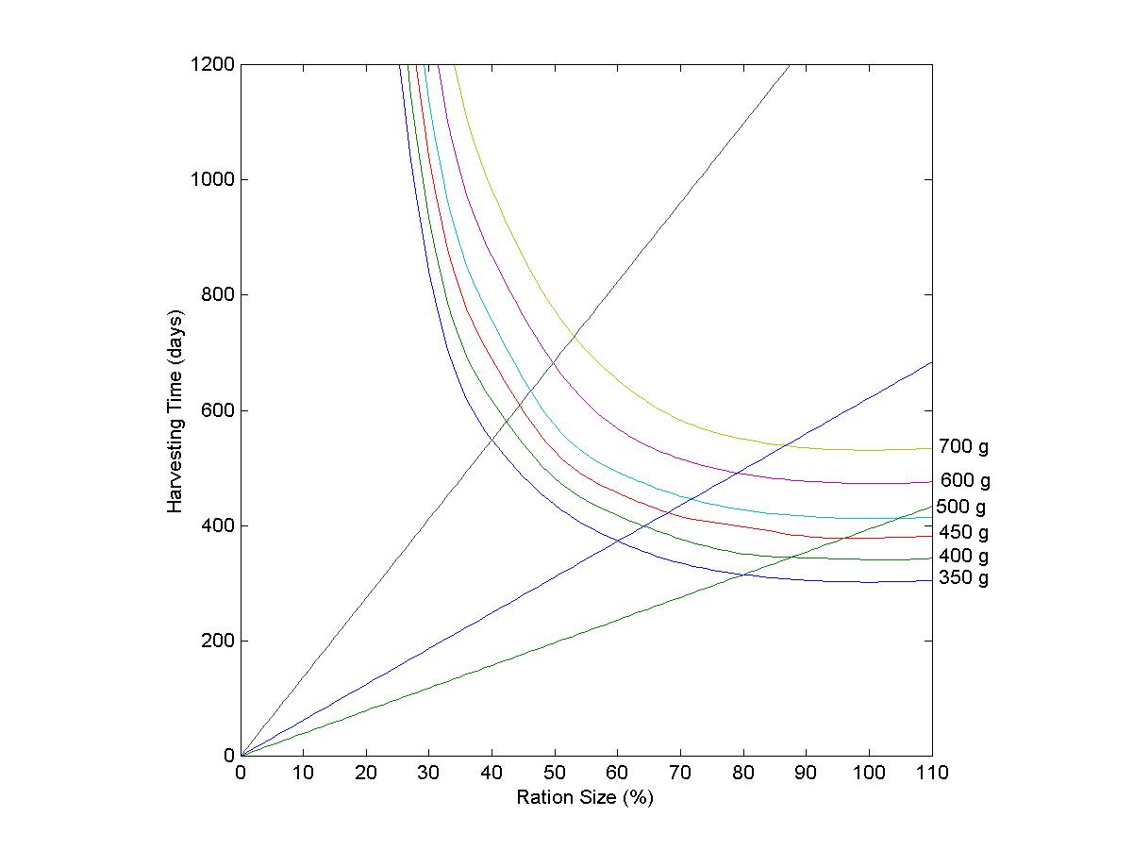
Figure 1. Isoquant map for different harvest weights.
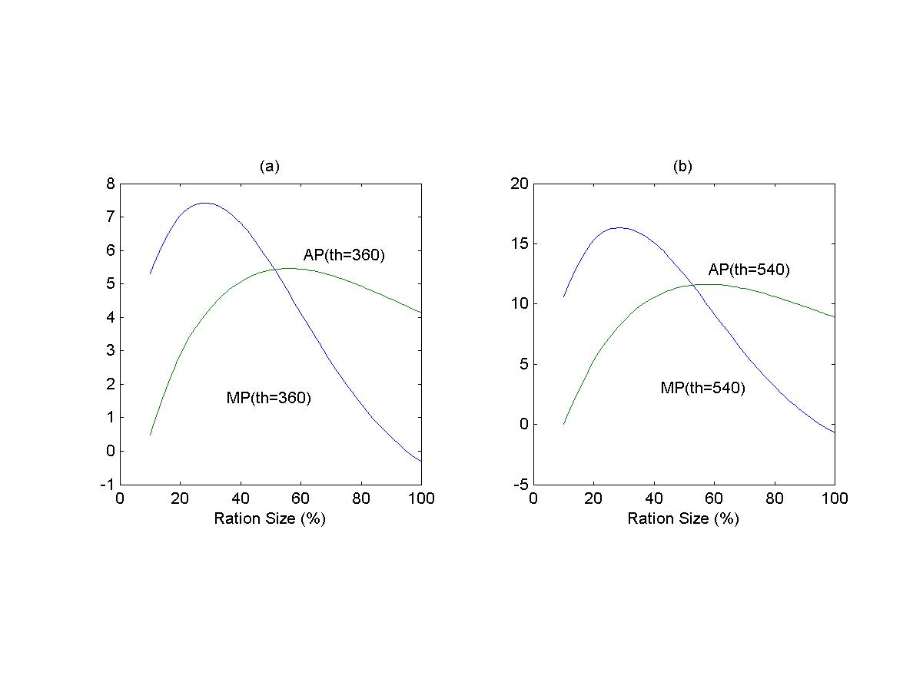

Figure 2. Marginal product (MP) and average product (AP) for the production function W(r,t_{h}).
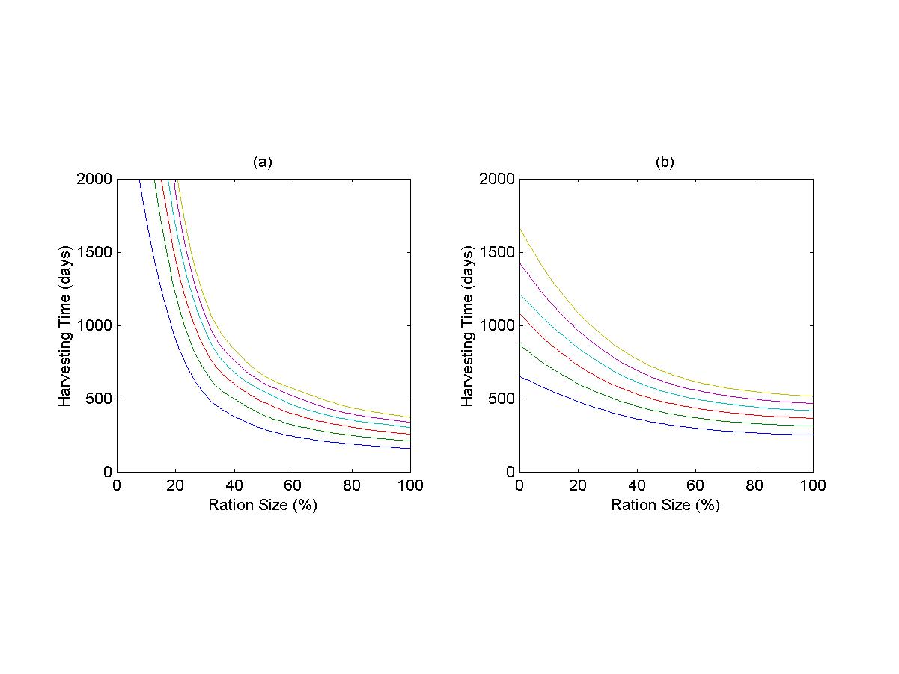
Figure 3. Isocost maps for: (a) C_{f}(r,t_{h}); (b) C_{T}(r,t_{h}).

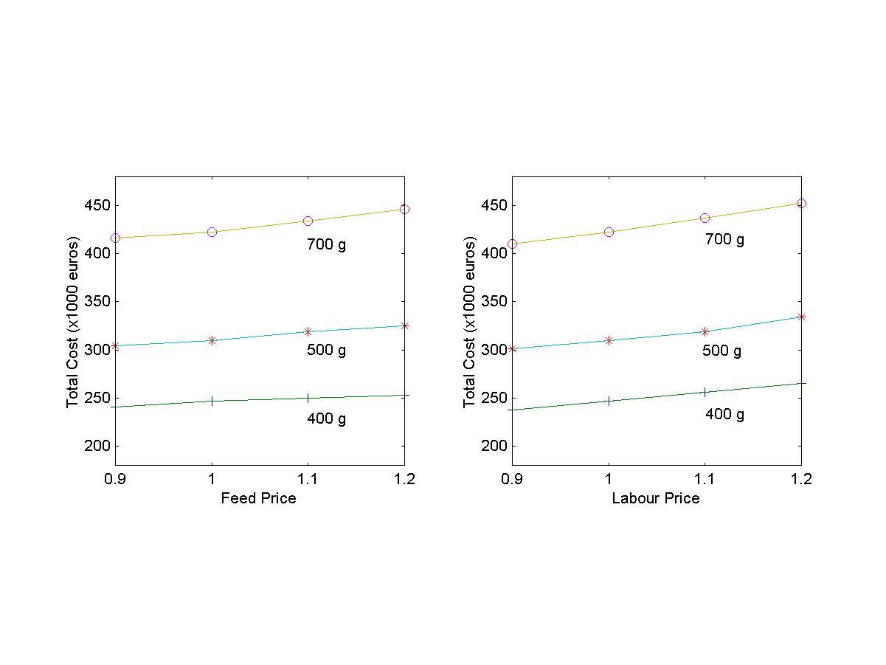
Figure 4. Total costs C_{T}(r,t_{h}) for different input prices. Price 1 indicates the base case.

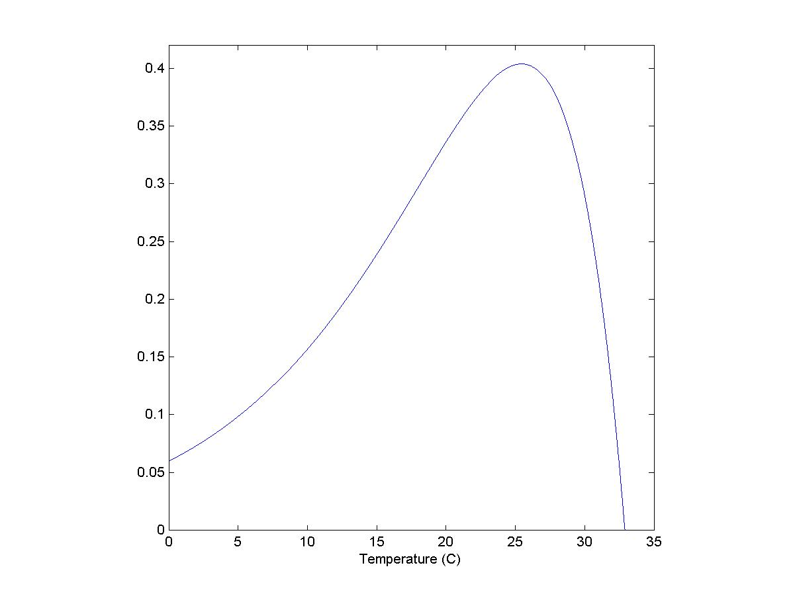
Figure A.1. Effect of temperature on fish growth (f₂(θ)).

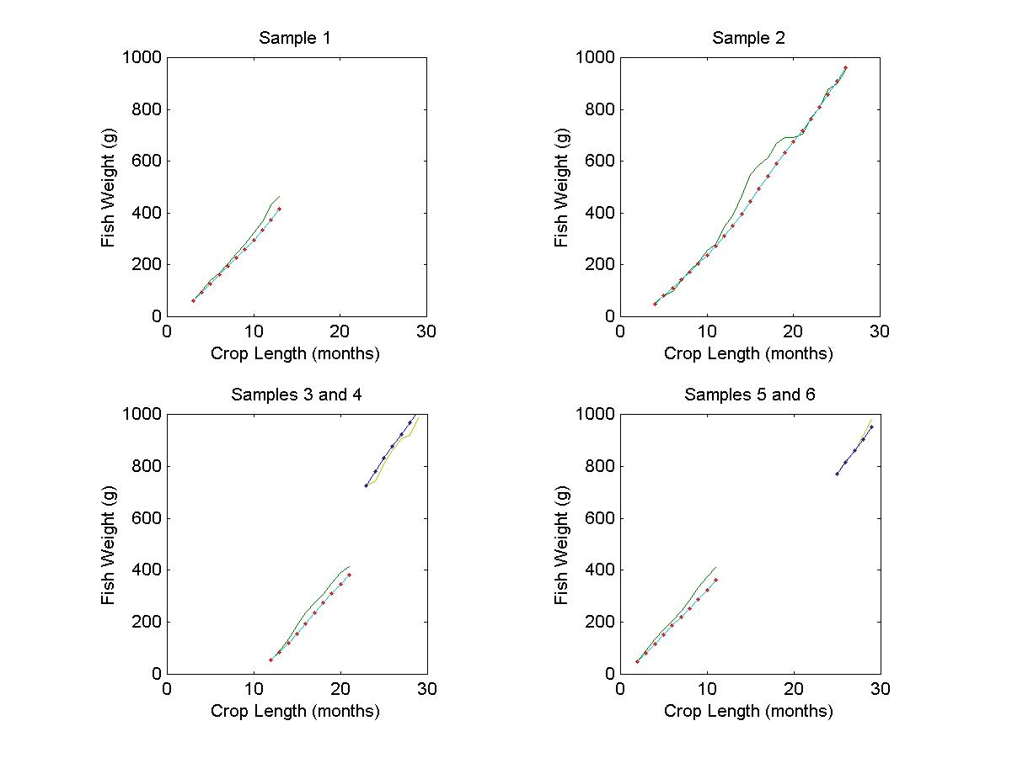
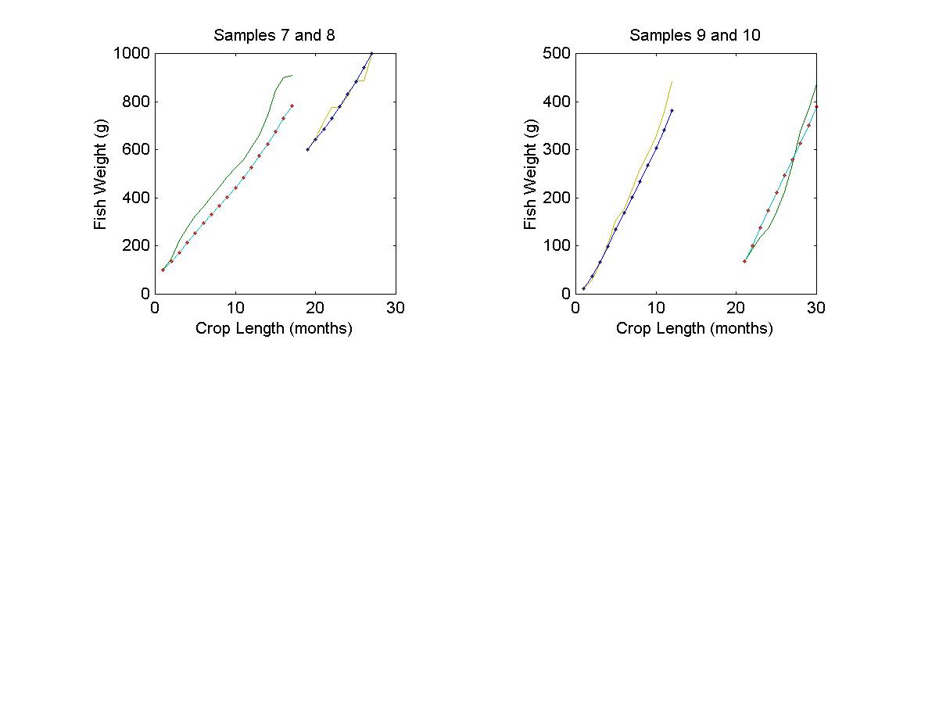
Figure B.1. Observed (continuous line) and simulated (pointed line) data samples for fish growth in six different floating cages.

These are the two inputs considered in optimal control problems for fish culture, such as Bjorndal (1988), Arnason (1992), and Heaps (1993). Mistiaen and Strand (1999) present an extension of this approach by including a piecewise continuous relationship between market price and fish weight.
Evidence shows that final market size varies from one country to another, following patterns of traditional local demand for seabream fisheries. As an example, consumers in France, Spain, United Kingdom and Switzerland premium large fish, while Greek and German markets prefer medium sizes. Nowadays, market segmentation has flourishing between smaller and larger sizes. This represents an opportunity for specialization in the warmer Southern sites by firms producing above 700 g. fish size.
The maintenance ration (r_{m}) is given by that feeding weight R_{m} for which acquisitions and expenditures of energy are equilibrated (nil growth), and the optimal ration (r₀) for the feeding weight R_{o} corresponding to the minimum conversion rate.
According to duality theory, cost minimization is inverse to profit maximization since the cost function is conjugate of the profit function. See Chambers (1988).
In this problem, farmers are assumed to evaluate total costs before stocking is accomplished. The interest is in solving for the optimal ration size to be undertaken through the optimal harvesting time. This approach makes calculations simple, and is appropriate to represent actual management practice in the production of seabream.
We assume an annual 6% interest rate.
The daily mortality rate is a two step function with a larger value for fingerlings (0.00064) than for individuals with more than one week (0.0000106). These values are low due to the environmental conditions of farming, and are not expected to significantly influence the optimal problem solutions.
The cost minimization problem was solved by using a ''graphical method''. This consists of representing the isoquants and isocost and detecting the tangency point between them. Level curves were determined by successive simulations of the model.
In consequence, the fish weight function W(r,t_{h}) can be shown to be quasiconcave. This is a sufficient condition for a well behaved production function, and it is necessary for the existence of an interior solution to a cost minimization problem, as shown in Appendix C.
This is due to the singular form of the normalized conversion rate Y(r). Nevertheless, it can be assumed that fish is not fed above satiation (R_{M}).
These are assumed to be the only factors affecting final fish weight. Of course, total plant production is determined by the capacity level and the amount of labor employed, but fish level results are supposed to be independent of these factors.
Some feed suppliers recommend 80% ration size as a general rule for seabream, whereas in practice farmers tend to exceed substantially this amount, approaching and overcoming 100%.
These results do not invalidate the findings by Mistiaen and Strand (1999). These authors find that the interest rate has a relevant effect on both the feeding rate and the harvesting time. These results follow from the assumption of a piecewise relationship between harvest weight and market price. In our model, harvest weight is given by market conditions (consumer preferences), and harvesting time adjusts accordingly.
The interest rate represents the opportunity cost of money for the aquaculture project. As the interest rate rises, this changes the relative rate of return for the project.

