Fundamental Difference in Fisheries Management
between the Western Countries and Japan

Tadashi Yamamoto *1

ABSTRACT

There is a fundamental difference in the structure of fishery between the Western countries and Japan, which is called hereunder “two areas”. The majority of fisheries developed in the Western countries are industrial fisheries like trawl or purse seine fisheries. In contrast, the mainstay of Japanese fishery are small scale coastal fisheries, though industrial fisheries have been developed.

Even in terms of access to fisheries resources, there is a great difference between the two areas. In the Western countries, access to the fisheries resources is free to anyone. (Open access) Under such a condition, the establishment of catch limit, is only the way to conserve the fishery resources. (Output control ) Conversely, in Japan, the access to the fisheries resources is limited to fishermen. (Limited entry) Therefore, the fisheries management is done mainly by restricting the number of fishing units. (Input control)

Naturally, under open access regime the number of fishing boats may increase, since there is no input control. Finally, the fishery may fall into an over investment and over fishing. The fishery management with catch limit alone is costly and technically difficult. By allocating the part of the total allowable catch to individual fishermen, IQ or ITQ syatem has been developed. Yet, to let fishermen follow the system properly, Monitoring, Control and Surveillance (MCS) are required at a great expense.

By 1949 Fishery law of Japan was throughly revised so as to allow fishermen to participate in the planning on optimum use of fisheries resources by means of fishing right and fishing license, which has resulted in the berth of collective fishery management by fishermen. (Community-based Fisheries Management System).

Above all, Western countries follows a top down management, the government being the manger of a fishery management, while Japan follows the bottom up management. In Japan, “neither compliance nor MCS problem exists. A possibility to introduce fishery management system developed in Japan to Asian countries exists, as the structure of fishery in those countries is the same as that of Japan.
１President and later on Honorary President, Japan International Fishery Research
Contents

1. Introduction

2. Fundamental Difference in Fishery Management between Japan and the Western
Countries
2.1 Difference in the Nature of Fisheries
- The Use of Aquatic Animals and Plants
- The Structure of Fishery
2.2 Difference in the Way of the Access to the Fisheries Resources
(1) Open access
(2) Limited Entry
(3) IQ and ITQ
2.3 Another Aspect of Difference between Limited Entry and Open Access

3. Significance of Japanese Fisheries Regime
3.1 Drastic Change in Japanese Fishery Regime After World War II
3.2 Current Status of Fisheries Management in Japan
- Fishery Management System under Limited Entry Regime
- Fishery Management System under TAC System

4. Current Status of Fisheries Management in the World
- (1) Is Limited Entry Inferior to Catch Limit under Open Access ?
(2) Is it Possible to Apply TAC System to Developing Countries ?

Attachment

1. Introduction

There is a fundamental difference in the way of fisheries management between the Western countries and Japan. Absence in the knowledge of such a fundamental difference has made it difficult for both (i) Japanese who wish to study fisheries management in Western countries and (ii) Western people who intend to study the Japanese fisheries management system. The present paper aims to provide basic knowledge and information with respect to how the way of fisheries management differs between Western countries and Japan. In the present paper, a term, “the Western countries”, refers to all developed countries other than Japan, and a term, “Fishery”, refers to marine fishery only.

In both the Western countries and Japan, fisheries resources are considered as the common property of people. In this respect, there is no difference between the Western countries and Japan.

However, for the use of fisheries resources the Western countries follows " an open access regime", which means that anyone is allowed to fish them. Under such open access regime, the government has to be the manager of fisheries resources, which means that the fisheries resources are under top-down management.

Japan, however, follows "limited entry regime" . The government allocates fishing ground/fisheries resources to fishermen by means of either fishing rights or fishing licenses. Both are regarded as a kind of territorial use rights in fisheries (TURF). Naturally, fishermen conceive that fisheries resources found in their fishing grounds are their own. With such a TURF, the Japanese community-based fisheries management system has been developed by the initiative of fishermen. This is called a bottom-up fisheries management.

Such great differences in fisheries management is not always clearly known to both Western countries and Japan. The open access regime has been followed even in many developing countries, where, in most instances, fisheries resources are considered as the government’s property. Nevertheless, some types of traditional fishing rights, which are also TURFs, have been developed in certain areas of Indonesia, Papua New Guinea and the Pacific islands countries.

2. Fundamental Difference in Fishery Management
Between the Western Countries and Japan

There is a fundamental difference in fishery management between the Western countries and Japan in terms of (i) the nature of the fisheries and (ii) the way of access to the fisheries resources.

2.1 Difference in the Nature of Fisheries
There are two fundamental differences in the nature of fishery between the Western countries and Japan in terms of ① the use of aquatic animals and plants for fishery and ② the structure of fishery.

- The Use of Aquatic Animals and Plants
In the majority of the Western countries, aquatic resources in use for fishery are
those, which inhabits in cold current. Therefore, the number of species are limited, but the abundance of each species is generally high. Such a situation of fishery resources facilitates the development of technically efficient fisheries like trawl and purse seine fisheries. This means that the pattern of fisheries in the Western countries are homogeneous.

Japan is located in a temperate zone with warm current in the south and cold current in the north. Therefore, a variety of aquatic fauna and flora are found in water around the country. Japan is historically a fishing nation as well as a fish eating nation. Therefore, Japanese fisheries make use of almost all these aquatic resources. Even poisonous fish like puffer, cephalopod, sea urchin, sea cucumber, sea squirt and sea weeds such as agar agar, undaria, kelp, etc., are utilized for fishery. To make use of these resources for fishery, a variety of fishing gears of different fishing function in different sizes have been developed. This means that the pattern of fisheries in Japan are heterogeneous.

- The Structure of Fishery
In the majority of the Western countries, industrial fisheries like trawl and purse
seine fisheries are the mainstay of the national fishery, though some small scale coastal fisheries are found in Greece, Italy, Norway, Portugal, Spain and United Kingdom. Again, the structure of fisheries in the Western countries is simple, being close to mono structure. Those industrial fisheries are based at limited number of fishing ports

In contrast to the Western countries, the mainstay of fishery in Japan is small scale coastal fishery, which is scattered all along the sea coast of Japan. They use small boat of less than 10 gross ton and employ a variety of different fishing gears. In fact, these small scale coastal fishery is the origin of Japanese fishery, which developed many centuries ago. In addition to this small scale fishery, since around 1920 Japan’s industrial fishery has developed, playing an important sector of her national fishery. Thus, Japanese fishery is composed of small scale coastal fishery and industrial fishery, which is known as a dual structure of fishery.

Above all, in terms of the nature of fishery, fisheries in many south and south-east Asian countries are quite similar to that of Japan, implying that the system of fishery management developed in Japan is applicable to those countries.

2.2 Difference in the Way of Access to the Resources
There is a fundamental difference in the way of access to the fisheries resources between Western countries and Japan. At present there are three different ways in the access to fishery resources as follows :

- Open Access
- Meaning of Open Access
When a question is raised to any American regarding the ownership of fisheries resource, we will get an immediate answer, saying that "fisheries resources are owned by people". This means that in the United States any American, regardless of whether he is a fishermen or not, is allowed to engage in fishing without a permission from the government. This is the meaning of "Open access" to fisheries resources. Professor Anthony Scott, a world leading economist, said that this kind of "Open access" regime originated in England a long time ago. In the past, the British conquered many parts of the world. As a result, such an open access regime has spread to many parts of the world.

- Catch Limit or Total Allowable Catch is the Way to Conserve Fishery Resources
Under an 'Open Access' regime in the Western countries, the most common way to conserve the fisheries resources is to establish "a catch limit", which is normally determined as a result of stock assessments. Such a catch limit is now called "Total Allowable Catch" or TAC. Under TAC system. Fishermen are allowed to fish until the total catch reaches the TAC. However, as entry into fishery is free to any person, the number of fishing boats tends to increase as long as the fishery is profitable. This will result in the over investment, which will lead over exploitation of fisheries resources. This has been a prevailing problem in the most of the Western countries.

- Some Examples on Free Access to Fishery Resources
In around 1992 the author was involved in an oil spill issue, which occurred in Alaska with an Exon oil tanker. In this regard, there was a meeting with a group of American lawyer. Incidentally, one of the lawyers told me that he was once a boat owner of salmon fishery in Alaska, as the salmon fishery was profitable. This is a good example that in the United States anyone can enter into a fishery without any restriction from the government.

There is another story, which took place in around 1965, when an otter trawl fishery was being developed on the west coast of the Malaysian Peninsula. In those days, trawl fishery caused severe conflicts with coastal fisheries. To control illegal operation of trawl fishery, the government established a regulation, by which a trawl fishery license was issued only in case where the applicant became the member of a trawl fishermen's society. However, in those days there was no limit in the number of the trawl licenses to be issued. As a result, many medical doctors, teachers, lawyers, etc. became the members of the society. This may be a good example of an open access policy, which was established by British colonial government for Malaysia.

- Problems Encountered to Follow TAC System
In the implementation of a fisheries management with TAC, there are two crucial issues to be tackled, i.e., (i) how to establish TAC which is assessed based on Maximum Sustainable Yield (MSY) and (ii) how to let fishermen to observe TAC.

For the assessment of MSY, annual series of catch and fishing effort data by areas of capture are absolutely essential. However, the collection of such an annual series of data is quite costly and is technically not an easy task. The size of TAC is determined based on MSY taking into account various social and economic conditions of the fishery. However, even in the Western countries, such statistical data are not always available. Under such a situation, a precautionary TAC, which is not assessed based on statistical data, is often used for the implementation of fisheries management.

Under the open access regime, an essential element of efficient fisheries conservation and management of fisheries resources is to establish appropriate monitoring, control and surveillance (MCS) systems. These are again very difficult and costly tasks, since fishing operation is performed at sea. A good number of inspectors as well as enumerators have to be stationed at many fish landing centers. Patrol boats may have to be dispatched to the fishing area. Observers have to be aboard commercial fishing boats.
In around 1980, foreign vessels still had been allowed to fish in the US 200 miles conservation zone of the Bering Sea. During this period, Professor Jon Sutinen studied on this issue and found that the total cost needed for MCS system in Bering Sea was slightly more than half of the total value of fish caught there. This study may well reveal how the fisheries management with TAC is costly and troublesome.

Furthermore, the TAC system alone tends to increase the size of fishing fleet, resulting in over investment and over exploitation of the fisheries resources. Over capacity of American trawlers, which occurred after all foreign vessels were phased out from the Bering Sea, is a good lesson. The same problem has happened in EU waters. Therefore, a special Chapter dealing with fisheries in the 1992 State of Food and Agriculture (SOFA), which is an annual report of FAO, strongly suggests to cease Open access policy in the fisheries management.

(2) Limited Entry
According to Japanese fishery law, the access to the fisheries resources is allowed only to fishermen by means of either a fishing right, which is granted to a Fishery Cooperative Association (FCA) or a fishing license, which is issued to an individual fishermen. This type of access to fisheries resources is called "Limited entry”.

Therefore, "limited entry" is completely opposite to "open access" in the way to the access to fisheries resources. In other words, it can be said that the fisheries management in Western countries is undertaken by regulating the size of catch, which is an output of a capture fishery. Conversely, the fisheries management in Japan is carried out by restricting the number and size of fishing boats, which is the input of the capture fishery.
- Development of Fishing Right and Fishing License System in Japan
The following will illustrate how Japanese fishing right and fishing license systems have been developed.

A. Fishing Rights
During the period of the feudal era of Japan, the whole area of the country was split into a number of administrative areas. For each of such a administrative area, a lord was assigned. The lord allowed a coastal fishing community to capture fish in a sea area right off their coast. In return, the lord collected tax from the coastal fishing community. This was the historical origin of the Japanese fishing right system. This original fishing right system ended by 1868, when the feudal government handed over its supremacy to the "Meiji" new government.

By 1901, the "Meiji" new government enacted so-called the "Meiji" fishery law by keeping the original idea of the fishing right system as developed during the feudal era. The "Meiji" fishery law stipulates that the fishing right will be granted only to a fishermen's society, provided that fishermen themselves will organize their fishermen’s society. This gave an utmost ideal opportunity to Japanese fishermen to have their own fishermen's organization.

By 1945, when World War II ended, "Meiji" fishery law was totally abolished, and current fishery law was enacted in the utmost democratic manner. However, the concept of the fishing right as a real right has been retained, although the contents of the fishing right have been considerably changed. Hence, 'Limited entry regime' has been maintained to the present.

B. Fishing License
Brief History of Fishery License System in Japan
In around 1920 when the 'Meiji' fishery law was in effect, a trawl fishery emerged, resulting in severe conflicts with coastal fisheries. To solve such a conflict, a fishing license system was newly created by limiting strictly the number of trawlers and its size and also by establishing a closed area for trawl fisheries for the entire sea area of Japan (See Fig. 1 in the Attachment). This was the first occasion, when Japan established a fishing license system. Since then, a similar fishing license system has been established for many other fisheries either at national or prefecture level.

Background for the Establishment of Fishing License System in Japan
The year of 1920 was a time, when a fishing boat of around 20 gross ton was mechanized with the development of semi-diesel engine. With the use of such medium-size mechanized boat a trawl fishery took place, causing many serious conflicts between the trawl fishery and coastal fisheries along almost all coasts of Japan. For this reason, it was at first considered that the trawl fishery was to be forbidden. Under such a circumstance, Japanese fishery license system was developed. Therefore, a fishing license in Japan is considered as a special fishing permit with several restricted conditions as specified in Table 3 in the Attachment to this paper.

Nature of Fishing License in Actual Practice
Since the fishing license is issued to an individual fisherman in limited number, it also falls under the limited entry regime. However, from the fisherman’s perspective the fishing license is a right to fish. Therefore, Japanese fishermen consider that the fishing license is a fishing right. The fishing license is transferable under certain conditions established by the government.

The fishing license system is established for each type of fishery, which employs a particular fishing gear and exploits particular resources in a particular sea area. As the fishing license is issued to an individual fisherman, such a fishing license can not be regarded as a fishing right as referred in A above. Nevertheless, there are many instances that fishermen who was granted a fishing license under the same fishing license system belong to a same FCA. The number of fishing licenses is strictly limited, and within a same fishing license system, fish to be caught by such fishing licenses is the same. Naturally, those fishermen conceive that those resources being exploited by them are their own, and create an idea of conserving these resources by themselves.

(3) IQ or ITQ System
The TAC system has developed under the open access regime. The greatest disadvantage of the TAC system alone under the open access regime is that the entry into the fishery is free to anyone, resulting in an unlimited increase in the fishing capacity, undoubtedly, this will result in an over investment and an over fishing to the fisheries resources.

To eliminate such an over investment and an over exploitation of resources, since the early 1980's, an individual quota (IQ) system or individual transferable quota (ITQ) system has been newly developed in some Western countries. This is done by allocating part of TAC to an individual fisherman as a quota, which is determined mostly in accordance with the size of catch realized by each fisherman in the past. This means that a fisherman with IQ or ITQ is allowed to fish until his catch reaches his own quota.

Difference between IQ and ITQ is that IQ is not transferable to others, while ITQ is transferable to others. Both are considered as a right to fish by an individual fishermen. However, from the fishermen’s perspective, either IQ or ITQ is a right to fish until his catch reaches his quota. However, from the viewpoint, ITQ may be more valuable than IQ, as it can be sold to others or can be bought from others.

From the fishery management viewpoint, both IQ and ITQ have several advantages. As IQ or ITQ is allocated to fishermen who were in existence at the time of allocation of quota, there will be no admittance for others to enter the fishery. As a result, with the introduction of IQ or ITQ, the fishery management has been shifted from the open access regime to the limited entry regime. A fisherman with IQ or ITQ can operate in fishing at any time within the fishing season. He is not required to improve the efficiency of his fishing boat to compete with other boats. Thus, from the economic viewpoint, the fisheries management with IQ or ITQ has brought about the most ideal situation to resources as well as fishermen.

However, the IQ or ITQ system has several disadvantages such as under report of his catch, discard of unwanted fish, etc. A Canadian, to whom the author met said that "a fisherman takes two, but he reports only one". IQ or ITQ system is established for a particular fish species, but a fishery, which aims at catching a fish with quota often catches other species simultaneously. The latter tends to be discarded into the sea soon after they were caught.

2.3 Another Aspect of Difference between Limited Entry and Open Access
There is a great difference in the object of fishery management between limited entry and open access.

In the former, the object of the fishery management is a certain fishery employing a specific gear and aiming at fishing particular species, which may be, many instances, plural species. In the case of the limited entry, for the purpose of fishery management, statistics on the number of fishing units, fishing effort and catch by species caught by a specific gear are required.

In the latter, the object of the fishery management is limited to particular species regardless of the type of fishing gear employed. Even in case of open access management, the number of fishing units by type of gear, fishing effort and catch by species are required for stock assessment. However, in the collection of fishery statistical data a focus is given to catch data by species. Thus, in Western countries, catch data broken by type of fishing gear employed and by species are hardly seen.

3. Significance of Japanese Fishery Regime

In those days, it has been widely known that a community-based fisheries management system (CBFMS) has been well developed in Japan with reference to the fishing right. However, the reason for its development is not always clearly known. As referred earlier, Japanese fishing right system was established in 1901 by the Meiji Fishery Law. However, the CBFMS developed only after 1949, when the current fishery law was promulgated.

3.1 Drastic Change in Japanese Fishery Regime After World War II

Over the past 250 years three fishery laws, "Ura" law (1743 - 1868), "Meiji" fishery law (1901 - 1948) and the current fishery Law (1949 - Present) were in effect. During the period of "Ura" law and "Meiji" fishery law, the government acted as a ruler, being superior to people. However, since Japan was defeated in World War II, under the policy of the Allied Occupied Forces, the government has become a civil servant, viz., an organization, which serves to people.

(1) Nature of Fishing Right before 1945
"Meiji" fishery law followed the system of a fishing right as developed during the feudal era as it was. Therefore, the fishing right granted by the “Meiji” fishery law was "an exclusive fishing right", which was effect to fish any aquatic animal and plant within a sea area assigned by the fishing right. With the progress of fishing boat mechanization, in compliance with the request from a FCA, the area of the exclusive fishing right was enlarged seaward. This resulted in the inclusion of migratory fish species and the use of mobile fishing gears into the exclusive fishing right.

A similar expansion of the area of the exclusive fishing right together with the inclusion of mobile fishing gear took place in every neighboring FCAs, which became necessary to establish a close coordination among FCAs concerned to make harmonious use of migratory resources by pooling the sea area of neighboring fishing rights, as mobile gears ought to have to move into the fishing area of neighboring fishing rights. Thus, the central government became a moderator to establish a fishery agreement among FCAs concerned. Actually, this was done by the central government by dispatching a task force to the area concerned.

(2) The Nature of Fishing Right After 1949
The policy of the allied forces, which occupied Japan for seven years from 1945 to 1952, was to make Japan as a democratic country in every aspect. In accordance with such a policy, the current fishery law was enacted in 1949 with the following directions :

- Nullification of All Fishing Rights Granted by Meiji Fishery Law
All fishing rights and fishing licenses which were granted by the "Meiji" fishery law were nullified. This made it possible to establish a fisheries management plan in a most democratic manner with the participation of fishermen through a regional fisheries coordination committee (RFCC).

b) Decentralization on the Task of Fishing Right from Central to Prefecture Government
The task of granting a common fishing right, which was formerly called “an exclusive fishing right”, was fully transferred from the central government to prefecture governments. This made it easier for the prefecture government to establish the fisheries management plan with the advice of RFCC.

c) Exclusion of Migratory Species and Mobile gear from the Coverage of Fishing Right
In the past, the exclusive fishing right, which corresponds to the present common fishing right, was effect to every fishing gear in use in the sea area of the fishing right regardless of whether it is mobile or non-mobile gear. Therefore, practically speaking, the exclusive fishing right was effect to every species available in the sea area of the exclusive fishing right.

In contrast to this, the present common fishing right is effect to (i) sedentary resources, (ii) non-mobile gear and (iii) seine net using non-powered boat and artificial fish reef/fish aggregating device, all of which are found within the sea area of the common fishing right. (For details, see Table 1 and 2 in the Attachment. For an example, see Figure 2 and Table 4 in the Attachment.) Thus, fisheries using mobile gears, which are excluded from the common fishing right are treated as either a license fishery or a free fishery, which does not require a fishing license.

d) No Change in the Contents of Fishing Rights for Large Set Net and Aquaculture
The systems of large scale set net fishing right and aquaculture right are maintained as they were in the past, with some minor modifications. (For details, see Table 1.2.)

e) Basically No Change in Fishing License System
The fishing license system, which was created during the period of "Meiji" fishery law, has been kept as it was. Therefore, the operation of mobile fishing gears like otter trawl, Danish trawl, purse seine aiming to fish migratory fish such as sardine, mackerel, boat seine, long line, etc. require a fishing license. As seen in Table 3. the operation of these gears are restricted not only by the number of fishing licenses but also by the size of fishing boat, closed sea area, closed season and fish landing port.
Mobile gears were excluded from the contents of a common fishing right. On the other hand, some new mobile gears have emerged with the advancement of fishing technology. Therefore, the type of mobile gears to be under the fishing license system has increased after World War II.

f) Establishment of Fishery Coordination Committee to formulate a Plan to democratic use of Resources in Prefecture Water
Of the many revisions made in the current fishery law, the most important one was the establishment of the "Regional Fisheries Coordination Committee" (RFCC) at every prefecture. The objective of the RFCC is to draw a fisheries management plan at a prefecture level, by allocating fishing grounds and fisheries resources available in the sea area off a prefecture in the form of either fishing right or fishing license. The RFCC consists of sixteen committee members, of which nine are elected among fishermen. However, the remaining seven are those who are acquainted with fisheries in the area, and they were appointed by the prefecture governor.

As may be imagined from the foregoing paragraph, the RFCC is quite capable of establishing the fisheries management plan for the benefit of fishermen. It may be also well imagined that the RFCC performs its job in a most democratic manner, as the majority of the RFCC members are elected among fishermen.

g. Establishment of Fishery Management Committee within FCA
Within FCA, by the fishery law, a fisheries management committee (FMC) was newly established. The objective of the FMC is to establish a plan to make democratic use of fishing ground or fisheries resources with reference to the fishing rights and licenses granted to the FCA. It may be well imagined that the FMC gives a motive to create the CBFMS.

  - Current Status of Fisheries Management in Japan
As is noted from 3.1 above, Japanese fishery management system has been developed basically under the limited entry regime. However, with the ratification of the UN Convention on the Law of Sea in 1996, Total Allowable Catch (TAC) system has also been developed for some commercially important species.

- Fishery Management System under Limited Entry Regime
In terms of the area of fishing operation, Japanese marine fishery can be broadly classified into three categories as listed below :

(a) Fisheries Operating in Sea Area off a Particular Prefecture.

(b) Fisheries Operating in Sea Area off more than Two Neighboring Prefectures,
including those operating in the entire sea area of Japan, and

(c) Fisheries Operating in the High Seas and the EEZ of Other countries.

Actually, fisheries under (a) and (b) are those, which operate within Japan's EEZ. Therefore, Japan is fully responsible for the management of these two fisheries. However, the fisheries management of fisheries under (c) requires an international cooperation.

(a) Fisheries Operating in Sea Area off a Particular Prefecture
The RFCC plays a key role in the formulation of a fisheries management plan at a prefectural level. Since the majority of the RFCC committee members are fishermen, the fisheries management plan will take into account the harmonious use of fisheries resources available in the prefectural water by means of the fishing right and the fishing license.

The prefecture governor issues fishing rights and licenses based on the fisheries management plan established by the RFCC. An example of fishing rights established for Shizuoka Prefecture can be seen in Figure 2 and Table 4 in the Attachment to this paer. Actually, fisheries operating in a sea area off the Shizuoka Prefecture are managed by ① 142 fishing rights, of which 20 are common fishing rights, 18 large scale set net rights and 104 aquaculture rights and ② 2,937 fishing licenses, which have been issued under 11 fishing license systems.

As referred earlier in Chapter 2, the sea area right off a prefecture is the sea, where a variety of different fishing gears, small and large, are in operation. However, since the fisheries management plan at a prefectural level has well taken into account of these situations, unlike the pre-war days, there has been little conflict among fishermen. Rather, the RFCC at the prefectural level and the FMCs at FCA level, which were formed under the current fishery law, have lead a great incentive to fishermen to create a community based fisheries management system (CBFMS).

By 1998, the total number of fishermen's organizations, which involved in the CBFMS throughout the entire area of Japan, accounted for 1,734. In fact, during the pre-war period when the "Meiji" fishery law was in effect, there were no CBFMS.

(b) Fisheries Operating in Sea off more than Two Neighboring Prefectures, including
those operating in the entire sea area of Japan
The type of fisheries, which fall under this category, is limited to few fisheries such as offshore trawl, large size purse seine, saury pike dip net, tuna long line and skipjack pole and line. Since they operate in sea areas off more than two provinces, the fishing license is issued by the Minister of Agriculture at national level.

Similar to the RFCC at the prefecture level, for fisheries as defined in the previous paragraph, the National Fisheries Coordination Committee (NFCC) has been established at national level to determine the number of fishing licenses, the size of boat/gear, closed sea area, closed season and the name of fishing harbor to land catch for easy monitoring and control of the licensed fisheries.

Of the several fisheries as referred above, the offshore trawl was the one, which once caused an over exploitation of demersal resources around Japan and a serious conflict with coastal fisheries. However, these problems have been no longer existed with the government’s effort to reduce the number of trawlers.

For other off-shore fisheries like purse seine, saury pike dip net fisheries, etc. which aims at catching pelagic migrating species, the central government has now introduced a TAC system for the reason that Japan has ratified the UN Convention on the Law of Sea in July This means that the TAC system, the idea which originated from the Western countries under the open access regime, has been introduced into Japan. However, neither individual quota (IQ) system nor individual transferable quota (ITQ) system has been applied due to the absence of such a necessity. Nevertheless, the TAC system may not be applied to fisheries, which fall under the category of (a) above.

(c) Fisheries operating in the High Seas and the EEZ of other countries
For the two reasons, Japanese government has a fishing license system even for fisheries, which operate in the High Seas and/or the EEZ of other countries. One is to establish a harmonious order of fishing operation and to keep a close linkage with domestic fishery, and the other to let these fisheries to observe international fishery agreements and/or to observe bilateral fishery agreements reached with other countries concerned.

- Fishery Management under TAC System
According to one of its Articles, the UN Convention on the Law of Sea stipulates that
a country concerned is to be responsible for the management of fisheries resources within her EEZ, and for doing so, the country should establish “Total allowable catch” (TAC) for each of commercial important species. As referred earlier, a fishery management by means of the TAC system has been developed in the Western countries, which follows an open access regime.

Since Japan has ratified the UN Convention on the Law of Sea, even in Japan, which follows basically a limited entry regime, TAC system has been partly applied limiting to six species, i.e., saury, Alaska Pollack, horse mackerel, pilchard (sardine), mackerels and Tanner crab. The most of catch of these six species have been caught under the current fishing license system, such as those for trawl fishery, purse seine fishery and so forth. Therefore, these six species are already under the management of both limited entry regime.

All of these species except Tanner crab are pelagic fish and hence migratory species, which do not fall under resources, which are in danger of over fishing. Only Tanner crab is a species, which is caught by trawl fishery and hence is apt to be over fished. Since 1997, when the TAC system has been introduced, the size of TAC for every six species has been worked out every year. The size of actual catch has hardly exceeded that of TAC, as it is said that the size of TAC has been worked our with good allowance.

Unlike many Western countries, neither IQ nor ITQ sytem has yet been applied, as the number of licensed fishing boats are strictly limited.

4. Current Status of the Fisheries management in the World

By concluding the present paper, the author would like to express two of his views based on his past experiences :

(1) Is Limited Entry Inferior to Catch Limit under Open Access ?
At one of the FAO meetings held in Canada right after the Wold War ll, the Japanese fishing license system was criticized for the reasons that even under the restrictive fishing license system with limited number of fishing licenses, the total fishing capacity may easily increase with the improvement in the fishing capacity of individual boats. This argument gave an impression to many resources manager that in the fisheries management, catch limit under the open access regime is superior to the fishing license system under the limited entry regime.

However, there many papers, which has revealed that the excess of fishing capacity and hence an over exploitation of fisheries resources have happened more in the Western countries than Japan. It is true that for the conservation of fisheries resources, catch limit system is logical, but it is so difficult and costly in its implementation.

Many FAO papers recently issued have suggested that "open access policy" should be terminated as early as possible. However, what to do after the open access policy is abolished is not mentioned at all. On the other hand, saying "limited entry" is likely to be a taboo in the Western countries.

(2) Is it Possible to Apply TAC to Developing Countries ?
The answer is no. TAC is obtained based on MSY. However, in developing countries there are no appropriate statistical data to derive MSY. The mainstay of marine fishery in developing countries is small scale fishery, which is scattered along the coast. Even when the appropriate size of TAC becomes available, it is not practical to apply the TAC system.

FAO sincerely recommends the developing countries to adopt a community based fisheries management system (CBFMS). For the implementation of the CBFMS, there must be a TURF or a fishing right. At the same time, there must be a fishermen's organization, which act as a core for the CBFMS. In doing so, national fishery law has to be revised. However, at present developing countries, which are ready to revise their fishery law so as to develop CBFMS are few.

References

Christy, F. T. 1992. "Territorial Use Rights in Fisheries : Suggestions for the Government Measures", FAO Fisheries Report No. 474 Suppl. Vol. 2 : 3, 78-365

Yamamoto T. : 1995. "Development of a Community-Based Fishery Management System in Japan", Marine Fisheries Resources Economics, Volume 10, 21-34

Yamamoto T. 2001. Collective Management of the Fishery in Japan, -Why Community-
based Fishery Management Has Been Well Developed in Japan ? –
Proceedings of the X IIFET Conference, 2001 Corvallis Oregon,
USA

Attachment

- Fishery Zone
Figure 1. Area closed for trawling
(Note) This is only a zone established by Japanese Fishery Law.

Specific Feature of Fishing Rights and License Defined by Japanese Fishery Law

Table 1. Specific features of Japanese Fishing Rights
- Common Fishing Right
- Large Scale Fishing Right
- Aquaculture Right
Table 2. Species Designated as Sedentary Resources For Type 1 of Common Fishing
Right
Table 3. Specific Features of Japanese Fishing License

Examples of Fishing Rights established in Shizuoka Prefecture

Figure 2. Example for Allocation of Fishing Area by Means of Common Fishing Right,
Large Scale Set Net Fishing Right and Aquaculture Right

Table 4. Contents of Fishing Rights as Established in Figure 2
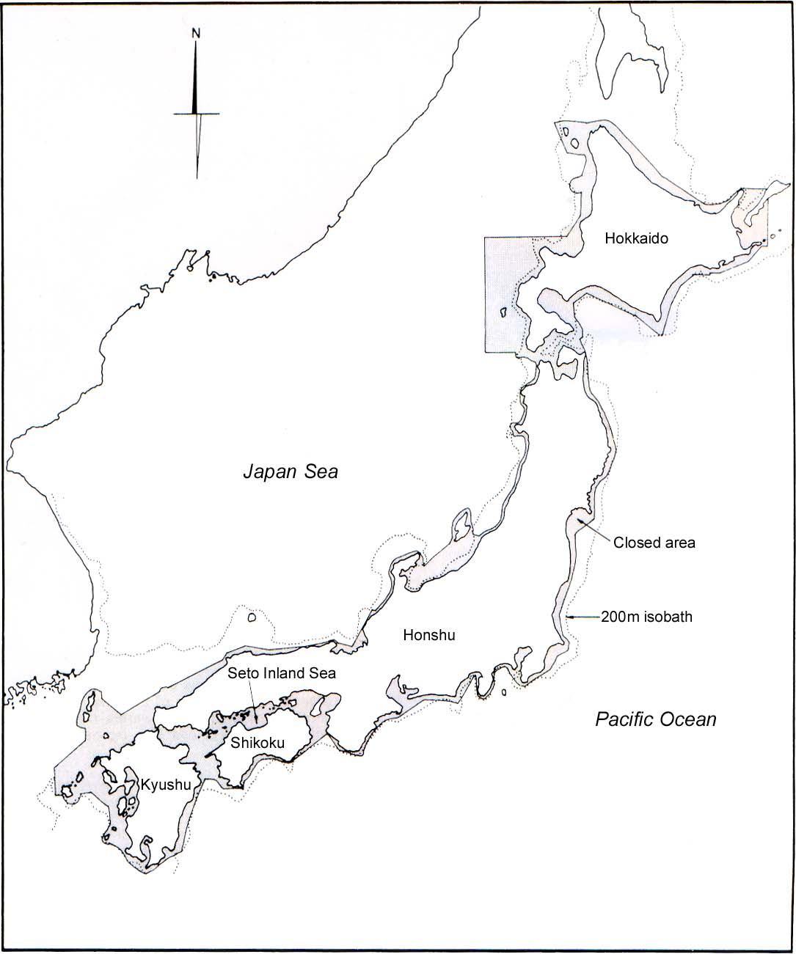
Figure 1. Area Closed for Trawling

(Note) Closed area for trawling, which was established in 1920.
For the detail, see B of 2.2 in the text of this paper.

Table 1. Specific Features of Japanese Fishing Rights (Continued)
- Common Fishing Right *1

Valid for 10 years and renewal with some modifications if necessary
(1) Component of the Right | (2) Sea Area, for which the Right is valid | (3) Right is Valid to | - Species mainly  Caught
Type 1  Right to capture (fish/harvest) sedentary resources | Sea area right off the coast of a fisheries co-operative association (FCA), which normally extend seawards 1 to 3 kilometer from the shore. *2 | The capture of sedentary species as specified in the right. | Species as specified in Table 2, e.g., kelp, agar-agar, spiny lobster, clam, scallop, abalone, top shell, sea urchin, etc.
Type 2  Right to operate non-mobile gear |  | The operation of  - Set gill net )  - Small scale set) net *3 )  - Basket  - Pot  - Tube | Fishes, spiny lobster, shrimp, top shell, etc.  Crabs  Octopuses  Sea conger
Type 3  - Right to operate seine net using non-powered boat and  ②Right to set artificial fish reef or fish aggregating device (FAD) |  | The operation of  - Beach seine or boat seine using  non-powered  boat.  - Artificial fish reef  - Fish aggregating  device (FAD) | A variety of species  Snapper, abalone, etc., which were artificially released.

* 1 : Common fishing right is granted to a fishery cooperative association (FCA).

* 2 : In a principle, a single sea area is established for all types of a common fishing right. (See Fig. 1) However, there is a case, that the fishing area is established for each type of the common fishing right separately

* 3 : The small scale set net refers to all set nets of any type and any size other than a
large scale set net as defined in (2) at the next page.

Table 1. Specific Features of Japanese Fishing Rights (Concluded)

- Large Scale Set Net Fishing Right * 1
(1) Legal Nature of Right | (2) The location of the fishing right | (3) Right is valid for | (4) Species Mainly Caught
Right to use a particular sea area exclusively to set and to operate a large scale set net. | Such a sea area is located mostly around the outer boundary of the sea area of the common fishing right. | Five years and renewal with some modifications if necessary. | ①For Hokkaido area, salmon is a target fish.  ② For area other than Hokkaido, yellowtail and blue fin tuna are the target fish, though various other fish are caught.

*1: A large scale set net is defined as a stationary set net, whose main net is set up at the depth of 27 meter at the time of maximum high tide. However, in Hokkaido a stationary set net of any size, which aims at catching salmon, is regarded as “Large scale set net”. A large scale set net is quite large in size and requires a big amount of capital. Therefore, this right is sometimes granted to an individual or company, in case where a FCA can not afford such a big amount of the capital.

- Aquaculture Right *1
(1) Legal Nature of Right | (2) Sea Area | (3) Right is valid for | (4) Species for Aquaculture *2
Right to use a particular sea area for rearing a particular species to commercial size. | Sea area, where aquaculture of a certain species is suitable.  Such sea areas are located mostly close to shore within the sea area of the Common Fishing Right. | 5 years and renewal with some modifications if necessary. | Fish: Yellowtail, sea bream, horse mackerel, puffer and flat fish.  Crustacean: Kuruma prawn.  Mollusk: Oyster, Scallop, abalone. And mother-of-pearl shell.  Seaweeds: Sea laver, Undaria and Kelp
*1 : In some literatures, this aquaculture right is called “Demarcated right”.
*2 : Aquaculture right is established for each species separately, and hence there is no case that an aquaculture right covers two species or more. It is normally granted to a FCA with an exception of pearl culture.
Table 2 Species Designated as Sedentary Resources
For Type 1 of Common Fishing Right *1

To keep a consistency throughout Japan, species which are regarded
as sedentary resources are designated by the central government. *1

- Seaweed *2  - Crustacean *2  3. Mollusc  3.1 Bivalve  3.2 Roll Shell  3.3 Cephalopod  4. Other Aquatic Animal | ○ Kelp  ○ Agar Agar  - Undaria  Sea laver  - Spiny Lobster  Mantis shrimp  ‘Hokkai’ shrimp  - Hard clam  - Short necked clam  - Hen clam  - Scallop  Cockle  - Abalone  - Top shell  - Octopus  - Sea urchin  - Sea cucumber  Star fish  Sponge  Angle worm (as a bait for angling)

*1 : In the above table, the name of species with ○ mark are those, which commonly appear as the component of many common fishing rights, Type 1. No fish is designated as sedentary species. However, in tropical countries, for example non-migrating fish such as climbing perch, goby, etc., which do not migrate beyond the sea area of the common fishing right could be considered as sedentary species.

*2 : In tropical countries, certain seaweed or sea grasses are used for home consumption of coastal fishermen. “Mangrove crab” could be also considered as a kind of sedentary resources.

Table 3 Specific Features of Japanese Fishing License

- A fishing license system has been established for “fisheries such as trawl, purse seine, drift gill net and so forth, which are in need of ① restricting its activity for the purpose of conserving fishery resources and/or ② eliminating any conflict with small scale coastal fishery.

- The fishing license is issued to an individual fisherman or a fishing company with many restrictions. It is valid for five years, and for its renewal certain conditions have been established.

- Owing to a difference in terms of the location of fishing ground, three broad categories of fishing licenses systems have been developed as seen in a table below. Prefectural fishing license is issued to a fishery, which operates within a sea area off a particular prefecture. National fishing license is issued to ① fisheries, which operate in sea area off two neighboring prefectures or more and ② fisheries, which operate in the high seas or EEZ of foreign countries. Thus, a fishing license is required, even when a fishing boat operates in High Seas or the EEZ of foreign countries, which are not under the jurisdiction of Japanese government.

- The table below indicates type of restrictions normally established for the fishing license. Such restrictions are determined for each type of fishery separately.

Broad Categories of Fishing License System | Sea Area | Fishing is Restricted in terms of
Broad Categories of Fishing License System | Sea Area | Number of Fishing licenses | Size of Fishing Boat in GRT | Closed Sea Area | Closed Season | Fish landing port
Prefecture Fishing License | Sea Area off a Prefecture | A | A | A | A | A
2.  National Fishing License | ① Sea Area off two neighboring prefectures | A | A | A | A | A
2.  National Fishing License | ② The High Seas and EEZ of other countries | A | A |  |  | Ａ

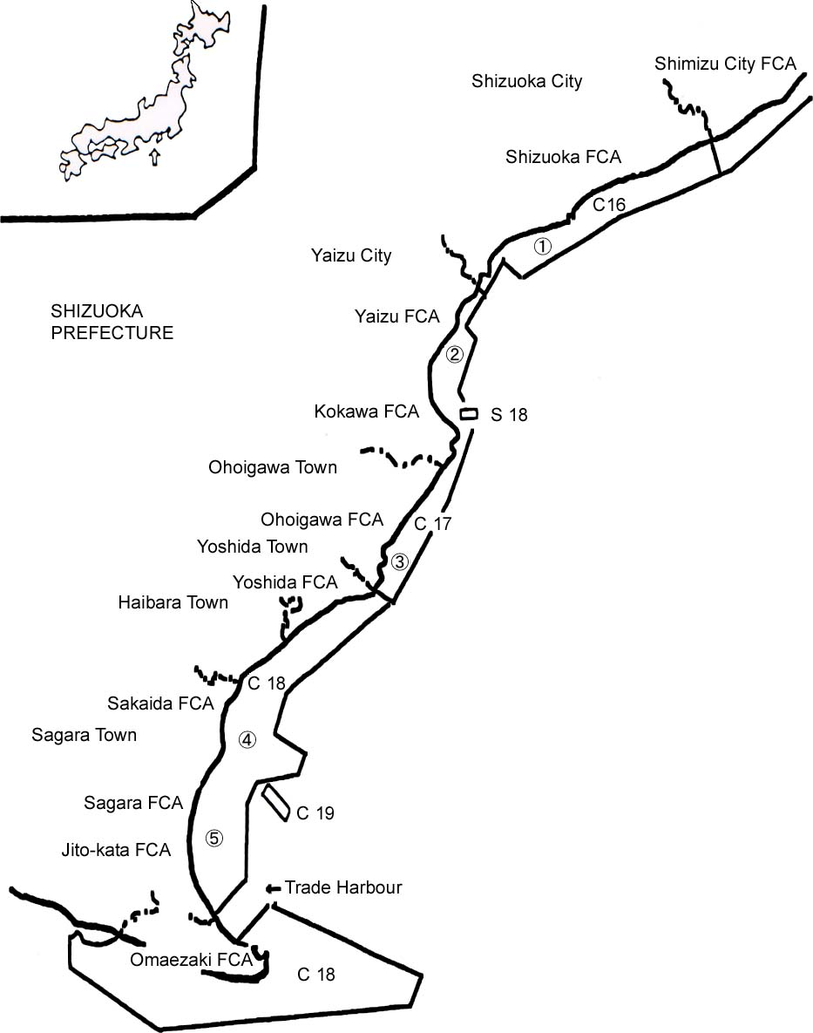
Pacific Ocean
C16 : Common Fishing Right No.16
S18 : Large Scale Set Net Right No.18
- ：Aquaculture Right No.1
FCA : Fisheries Cooperation Association
LEGEND
0 5km

Figure 2. | Example for Allocation of Fishing Area by Means of  Common Fishing Right, Large Scale Set Net Right and  Aquaculture Right

Table 4 Contents of Fishing Rights as Established in Figure 2
(Shizuoka Prefecture)

A table below shows the details of several fishing rights established for the western part of Shizuoka Prefecture. (For actual location of each fishing right, see Fig. 2)

- Common Fishing Right (CFR)
Serial No. of CFR and Name of FCA  *1 | Type 1  For Sedentary Resources | Type 2  For Non-Mobile Gear | Type 3  For Non-powered Seine & Fish Reef
16 Shizuoka City | Lobster, Top shell, Abalone, Octopus and Sea urchin | Rock fish gill net | Beach seine
17 Yaizu, Kokawa and Ohoigwa | Lobster, Top shell, Oyster, Whelk,  Sea urchin,  Sea cucumber and ‘Arame’ seaweed. | Rock fish gill net and “Konoshiro” stow net | Beach seine and Artificial fish reef.
18 Yoshida, Sakai, Sagara, Jizoukata and Omae-zaki | Lobster, Abalone, Oyster, Hard clam, Top shell, Octopus and ‘Arame’ | Rock fish gill net and “Konoshiro” stow net | Beach seine and Artificial fish reef.
19 Sakai, Sagara, Jizoukata and Omae-zaki | Lobster, Abalone, Top shell and ‘Kajime’ seaweed. | Rock fish gill net
*1 : It will be noted from this table that CFR No. 16 has been granted to Shizuoka City FCA only
. However, CFR No. 17, 18 and 19 have been granted to two neighboring FCAs or more.

- Large Scale Set Net Fishing Right
Serial No. | Name of Fisherman, to whom the fishing right was granted. | Location | Species to be caught
18 | Mr. Takayuki Hasegawa | Off Tajiri Beach | Yellowtail & Mackerel

- Aquaculture Right
SerialNo. | Name of FCA, to whom the fishing right was granted. | Location | Species for culture
1  2  3  4  5 | Shizuoka City  Yaizu  Ohigawa  Sakaida  Sagara | Off Iwabe beach  Off Hama beach  Off Ohigawa beach  Off Sakaida town  Off Sagara beach | Undaria  Scallop & Oyster  Undaria  Undaria  Horse mackerel and Sea bream
Note : In Fig. 2, the place of these aquaculture right is indicated by ○ mark. However,
the actual area of a aquaculture right is normally a square size.

