COASTAL ZONE MANAGEMENT IN THE DUTCH WADDEN SEA
‘Creating win-win-solutions’

Marius van Wijk
LEI, Fisheries Department

Abstract

This paper aims to describe a analytical framework which has been used to identify win-win situations for the ecosystem and the shellfish industry in the Dutch Wadden Sea. In this framework both ecological and economical criteria are analysed to evaluate management decisions regarding limitations to fisheries.

The Wadden Sea is an important nature conservation area and also an important fishing ground. In the first part of the paper a short description of the ecological value of the Wadden Sea is given. Than the economic value of this area for the Dutch fisheries in general and the shellfish industry in particular will be described. After this follows a short perspective on the management policy and the co-management framework which has been instituted involving all relevant parties at different institutional levels. Than some analytical tools are presented which are generally being used to analyse coastal zone management problems such as the Wadden Sea-case. The paper than describes the analytical framework which has been chosen for this study and ends with an general discussion of the results

Ecological value of the Wadden Sea

The Wadden Sea is a tidal area extending from the north-west corner of the The Netherlands along the coast and islands of the German Bight to Esjberg in Denmark. It is a network of tidal channels, sandbars, mudflats, salt marshes, 23 islands with sand dunes and 14 high sands, covering about 9000km². Approximately 30% of the Wadden Sea falls under the jurisdiction of the Netherlands.

The Wadden Sea is Europe’s largest wetland ecosystem and one of the largest in the world. It is characterised by a very high biomass production and an ecological importance extending far beyond its borders. The area forms one of the most important habitats for coastal waterfowl and shorebirds in the world and is the most important staging area and point of distribution for migration birds in Europe. A number of sea mammals are indigenous to the area. Furthermore, the Wadden Sea is the residence of numerous fish species and an important nursery area for fish species from the North Sea and surrounding coastal waters.

Besides being economically important for fisheries, the Wadden Sea is also being used for recreational purposes, military defence and the extraction of minerals and gas.

Economic value for Dutch fisheries

The Dutch Wadden Sea has been an important fishing ground for centuries. Nowadays shrimp, cockles and mussels are the dominant species.
There are about 90 licence holders for the shrimp fishery in the Wadden Sea. Most vessels are rather old and have an engine capacity of less than 221 kW. The Wadden Sea accounts for 50-75% of the total value of landings of the Dutch shrimpers.
In the cockle fishery, two types of fishery are distinguished: (i) the mechanical sector, which uses hydraulic suction dredges to fish cockles, and (ii) the non-mechanical sector, which uses the traditional hand-dredge. About 20 vessels are active in the mechanical sector. As the cockle stocks show significant fluctuations, annual landings vary strongly. The Wadden Sea accounts for almost all of the value of landings.
The mussel fishery is a semi-culture, concentrating on the bottom cultivation of wild mussel seed on parcels, which are rented from the state. These parcels are located in the Wadden Sea and the waters of Zeeland. Most of the mussel seed is caught in the Wadden Sea. About 75 vessels are active and total value of landings varies between 80 and 120 mNLG. The Wadden Sea parcels accounts for half of the landings.

Table 1.Value of landings Dutch fleet according to fishing area and fishing technique*

 | 4-year average, 1996-1999, mNLG**
 | Total | Wadden Sea | Coast of North and South Holland | Waters of Zeeland | Outside 12 mile-zone
Total | 1,239.3 | 177.1 | 51.2 | 112.3 | 898.8
Beam trawl | 641.7 | 32.0 | 32.4 | 33.3 | 544.0
Roundfish | 39.8 | 1.1 | 4.5 | 4.9 | 29.3
Other cutter fishery | 9.8 | 1.8 | 2.6 | 0.8 | 4.6
Shrimps | 73.5 | 55.7 | 11.7 | 6.1 | -
Cockles | 32.3 | 28.6 | - | 3.6 | -
Mussels | 113.9 | 57.8 | - | 56.1 | -
Pelagic | 320.8 | - | - | - | 320.8
Other | 7.5 | - | - | 7.5 | -
*Source : Impact of coastal works on the Fisheries, 2001, LEI
**1 Euro = 2.20 NLG

Coastal Zone Management in the Wadden Sea

Fishery was not considered to be a major thread to the ecological value of the Wadden Sea until the early nineties. No limitations were in place. In 1990 however, nature conservation groups asked attention for the death of thousands of birds which was, in their believe, caused by the cockle fishery. Furthermore they claimed that unrepairable damage had been done to rare eelgrass and wild mussel beds. This claims led to long and heated discussions between the industry, government and conservation groups.
As a result of this in 1993 the Sea and Coastal Fisheries Policy (SCFP) was implemented. The policy is built around two central themes:
- the division of responsibilities between the fishing industry and the government;
- the integration of fisheries and nature.

As a result of the policy, about 26% of the Wadden Sea has been closed for cockle fishing and mussel seed fishing to protect the development of mussel and cockle beds and eelgrass. Furthermore each year is determined whether enough food (cockles, mussels etc.) is available in the Wadden Sea for the birds, on the basis of a stock inventory. If the food supply is not sufficient, the fishery has to be closed.
The shellfish industry, in collaboration with nature conservation groups, was responsible for the design and implementation of a Shelfish Fisheries Management Plan, in which the principle of integration of fisheries and natural environment in the coastal waters is shaped through tangible agreements. Some of the measures taken:
- implementation of yearly fishing plans;
- reduction of fishing capacity;
- control system (black box on board) and heavy sanctions;

Responsibilities for the fishing plans were transferred to Producers Organisations (PO’s) of which most of the fishermen became a member. The PO has statutory powers to impose sanctions.
Implementation of the SCFP in the year 1993-1997 has resulted in a heavy economic losses for the cockle sector due to the closing of fishing areas. In these years fishing opportunities were already lacking because of natural causes. The mussel sector did not suffer much as a result of SCFP.
Compliance rates with the fishery regulations have been very high until now, even after in recent years more limitations have been imposed on the fisheries. However, nature conservation groups still question the presence of in particular the cockle fishery in the Wadden Sea. Heavy debate between the industry and these groups continues until this moment, both sides trying to influence the government and public opinion.

In the process of formulating a new SCFP for the next years the industry has pushed the idea of a revision of the closed area-policy. Some closed areas of low ecological value but high value for fisheries could be opened again. In exchange for that areas which are now open for fisheries but have little economic value could be closed if this would benefit nature values.
The Dutch Parliament has adopted this idea and has asked the Ministry of Agriculture and Fisheries to look at possibilities for creating win-win-alternatives for both fisheries and nature. Besides the exchange of areas other possible win-win alternatives should be considered as well such as a more flexible closed area-policy. The Ministry has asked a number of biological research institutes to research all these options while LEI was asked to look at the economic consequences.

Economic aspects of Coastal Zone Management

Typical coastal zone problems such as the Wadden Sea case, with lots of conflicting interest, can be analysed in a number of ways.
Generally speaking the economic aspects of this can be taken account by using qualitative and quantitative methodologies. An example of a quantitative methodology is the cost-benefit approach in which the effects op policy options are expressed in financial terms as much as possible. Shadow prices must be estimated if there are no market prices available. Several approaches can be taken in this respect:
- use-value : the value that individual people attribute to an object on the basis of their use of it. For instance the value that a hunter gives to the wild animals he is chasing.
- Option value : the value that individual people attribute to an object because they might want to make use of it in the future;
- Intrinsic value : the value that individual people attribute to an object regardless of their present or potential use of it.

Estimation of these values can be done in an indirect way, by comparing individual behaviour when choosing between alternative options. For instance the difference between the price of a house in a peaceful area and that in a busy place, gives an indication of the value of policies regarding noise reduction.
Estimations can also be made in a direct way, by asking people directly through enquiries about their valuation of different options (Contingent Valuation Method). There are however some problems with this method such as the information bias, if the respondent is influenced by information presented by the research team, or the hypothetical bias. This means that the fact that the respondent does not have to pay real money might influence his answer. Furthermore there are some ethical issues such as intergenerational equity. In particular in the case of environmental policy options it can be argued that the opinion of future generations is just as valuable as the opinion of individuals in this time period.

It is not always useful or possible to calculate shadow prices. In this case qualitative methodologies such as the multiple-criteria analysis can be used. Multiple-criteria analysis form a group of non-monetary evaluation methods which allow for a comparison and ranking of alternative options. A simple form of this is weighted injunction in which for each alternative the standardised scores are multiplied by their weight and than added up. Another category of multiple-criteria analysis makes use of methods in which each alternative is compared in pairs with another alternative for each criteria seperately.

Because of the above mentioned problems with the cost-benefit approach and limitations to the research budget, a simple form of the multiple criteria analysis has been used in the Wadden Sea case.

Creating win-win options

The multidisciplinary research team was asked by the Ministry to evaluate several policy options which could lead to a win-win situation. Furthermore some options were put forward by the industry. It was decided to limit the evaluation to the following policy options regarding fisheries in the Wadden Sea :

- opening of areas which are now closed for cockle fishing activities in return for closing of other areas;
- different organisation of the fishing activities resulting in a smaller part of the Wadden Sea being fished;
- opening of areas for mussel seed fishing which have low potential regarding development of stable mussel banks in return for limitations to fisheries elsewhere;
- relocating of young cockles to areas with higher growth potential.

Most of the work of the research team was concentrated on policy option 1, partly because there were too little data available to analyse the other ones and partly because option 1 was the most political controversial one. Nature conservation groups have opposed the idea of option 1, contrary to the industry who supports the idea.

The policy options were to be evaluated according to the following 4 criteria’s, the first three relating to nature values and the last one reflecting on the interest of fisheries:

- the level of damage to areas which have been undisturbed for some time;
- the consequences for the food supply of birds;
- the influence on the chances for new stable mussel beds and eel grass fields;
- the effects on the economic position of the shellfish industry.

The following arbitrary scores were used to evaluate the options against the criteria :

- significant gain : +3 points
- some gain : +1 points
- no effect : 0 points
- some loss : -1 points
- significant loss : -3 points
- unknown : 0 points

In table 2 an example is given of how this calculation works with respect to the criteria ‘chances for new stable mussel beds and eel grass fields’.

Table 2 Evaluation of chances for new stable mussel beds and eel grass fields for different areas

 | Chance on musselbeds | Chance on eel grass | Combined score
Opening of area :
Balgzand | -3 | -1 | -2
Piet Scheve | -1 | -1 | -1
Uithuizen- small | -1 | -1 | -1
Uithuizen-large | -3 | -1 | -2
Closure of area :
Schierm'oog | +1 | +1 | +1
Vlieland | +1 | +1 | +1
Ameland-coast | +3 | +1 | +2
Ameland-large | +3 | +1 | +2
Griend | +1 | +1 | +1

Similar calculations were made with respect to the other ‘nature’ criteria : ‘damage to areas which have been undisturbed for some time’ and ‘consequences for the food supply of birds’.
Combining the results of the three ‘nature value’ criteria in the following table results in an average score with respect to each area and the effects opening or closing would have on nature values.

Tabel 3 Combination of the scores for nature

 | Damage to undisturbed areas | Food supply birds | Mussel beds and eel grass fields | Average

Opening of area:
Balgzand | - 3,0 | - 3,0 | - 2,0 | - 2,67
Piet Scheve | - 3,0 | - 2,5 | - 1,0 | - 2,17
Uithuizen- small | - 3,0 | - 1,5 | - 1,0 | - 1,83
Uithuizen-large | - 3,0 | - 3,0 | - 2,0 | - 2,67
Closure of area: | Damage to undisturbed areas | Food supply birds | Mussel beds and eel grass fields | Average
Schierm'oog | + 1,0 | + 1,5 | + 1,0 | + 1,17
Vlieland | + 1,0 | + 1,5 | + 1,0 | + 1,17
Ameland-coast | + 1,0 | + 1,5 | + 2,0 | + 1,50
Ameland-large | + 1,0 | + 3,0 | + 2,0 | + 2,00
Griend | + 1,0 | + 1,5 | + 1,0 | + 1,17

To account for the differences in surface of the different areas the average scores have to be weighted. This is done in table 4.

Table 4 Combined scores multiplied with surface area

 | Surface | Average score | Weighted score  (divided by 1000)

Opening
Balgzand |  | 9000 | -2,67 | -24,03
Piet Scheve |  |  | 1400 | -2,17 | -3,04
Uithuizen – small |  |  | 3400 | -1,83 | -6,22
Uithuizen – large |  |  | 8700 | -2,67 | -23,23

Closure
Schiermonnikoog |  |  | 3000 | +1,17 | +3,51
Vlieland |  | 4300 | +1,17 | +5,03
Ameland – coast |  |  | 5000 | +1,50 | +7,50
Ameland – large |  |  | 6800 | +2,00 | +13,06
Griend |  | 7000 | +1,17 | +8,19

This table can be analysed to evaluate whether a win option is possible for nature values. Opening of eg. the area Balgzand (-24,03) and closing of Schiermonnikoog (+3.51) results in a net loss for nature values of –20.52. In the same manner different combinations of opening and closing of areas can be analysed.

Effects on the economic position

The effects on the economic position of the industry has been analysed in two different ways:
- effects on the average value added of the industry;
- effects on the continuation prospects of the industry.

Data about the stock of cockles in the different areas was available from the last 11 years. The average for this period could be compared with the average stock of cockles in the whole Wadden Sea. This gives an indicaton of the potential relative loss or gain in volume of catches with repect to each area. Furthermore a price flexibility of –0.25 was taken into account, meaning that an increase in catches of 10% leads to average price decrease of 2,5%. In this way the effects on the average value added can be estimated.

The effects on the continuation prospects of the industry was analysed on the basis of the risk profile of each area. The volume of cockles in the Wadded Sea is dependent on nature and therefore highly variable from year to year. Opening of areas with a high chance of cockles being available in most of the years is therefore important for the continuation of the industry while areas which have cockles only occasionally are less important.

After this a similar scoring exercise as with the nature values has been done, eg. opening of an area with obvious gains for average added value or obvious gains with respect for continuity scores +3 points and so on.

Tabel 5 Combination of the scores for the economic position

 | Value added | Continuation | Combined score

Opening of area:
Balgzand | +1,0 | + 1,0 | + 1,0
Piet Scheve | 0 | 0 | 0
Uithuizen- small | +1,0 | + 1,0 | + 1,0
Uithuizen-large | +1,0 | + 3,0 | + 2,0
Closure of area:
Schierm'oog | -1,0 | - 3,0 | - 2,0
Vlieland | - 1,0 | - 3,0 | - 2,0
Ameland-coast | 0 | 0 | 0
Ameland-large | - 1,0 | - 1,0 | - 1,0
Griend | - 1,0 | - 1,0 | - 1,0

To account for the differences in surface of the different areas the average scores have to be weighted. This is done in table 6.

Table 6 Combined scores multiplied with surface area

 | Surface | Combined score | Weighted score  (divided by 1000)

Opening of area
Balgzand |  |  | 9000 | 1 | +9
Piet Scheve |  |  |  | 1400 | 0 | 0
Uithuizen – small |  |  |  | 3400 | 1 | +3.4
Uithuizen – large |  |  |  | 8700 | 2 | +17.4

Closure of area
Schiermonnikoog |  |  |  | 3000 | -2 | -6
Vlieland |  |  | 4300 | -2 | -8.6
Ameland – coast |  |  |  | 5000 | 0 | 0
Ameland – large |  |  |  | 6800 | -1 | -6.8
Griend |  |  | 7000 | -1 | -7

This table can be analysed to evaluate whether a win option is possible for the economic position of the fisheries. Opening of eg. the area Uithuizen-large (+17.4) and closing of Schiermonnikoog (-6) results in a net gain for the economic position of 11.4. In the same manner different combinations of opening and closing of areas can be analysed.

Conclusions

The research team was well aware of the fact that many rather arbitrary decisions have been made in this analysis regarding scoring points, weights, relevant criteria etc.. However sensitivity analysis shows that using other points or criteria weights doesn’t lead to a significant change in conclusions.

The main conclusions of the study are :

- Opening of areas for fishing activities in return for closing of other areas can only benefit nature values if a relatively larger area is closed. Exchange of areas of equal surface has no positive effects for nature.

- The economic position of the industry will probably benefit from exchanges, in particular if the area ‘Uithuizerwad large’ is opened in combination with closure of two or three other areas.

- Some gains for both nature and industry are possible but significant gains can not be expected.

In the year 2003 a decision will be made about the future of the cockle fishery in the Wadden Sea. Nature conservation groups are pushing hard for a total ban for all cockle fishing activities and they are supported by some political parties.

References

All hands on deck, N.A. Steins, Thesis Wageningen University, 1999
Economic aspects of Coastal Zone Management, F.C. Buisman, LEI, Mededeling 567, 1996
Searching for Win-Win-situations for nature and industry in the Wadded Sea, RUG e.a., 2001
Impact of coastal works on the Fisheries, 2001, LEI
Fisheries in Figures, LEI, 2000

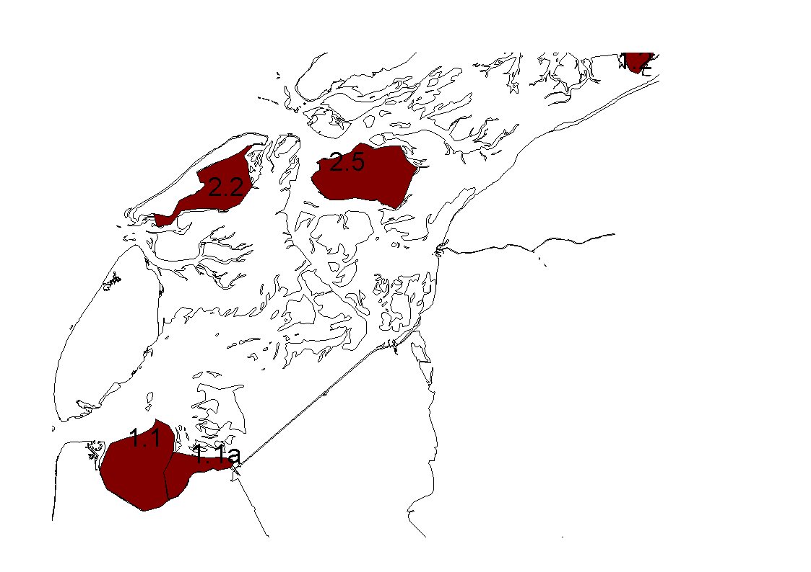

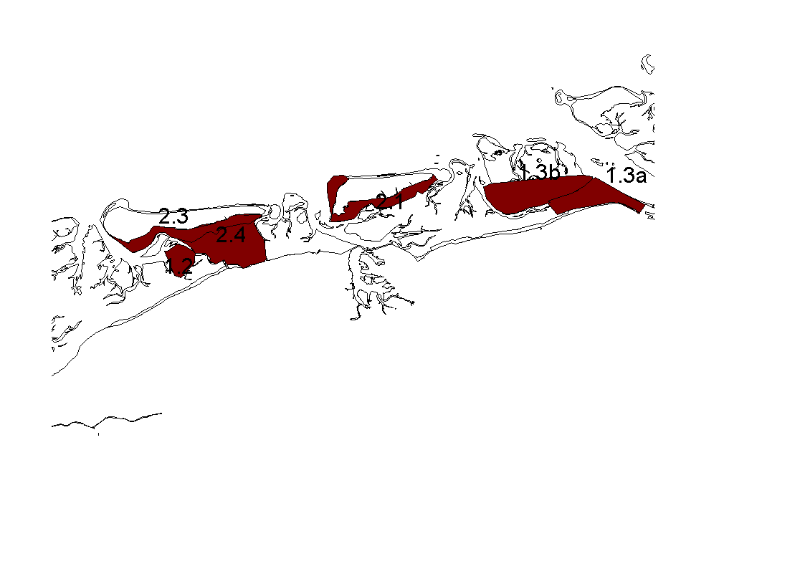
Figure 1 Global location of win-win-areas in the Wadden Sea

N. Steins, All hands on deck, Thesis Wageningen Universiteit, 1999
Economic aspects of Coastal Zone Management, F.C. Buisman, LEI, 1996

