Stability and optimal harvest policy in a dynamic model of fishery

Vílchez-Lobato, M0 Luisa

Herrero, Ines

García-Hoyo, Juan J.

Department of General Economy and Statistic
University of Huelva
Plaza de La Merced s/n
SPAIN
lobato@uhu.es
iherrero@cica.es
hoyo@uhu.es

Abstract

This paper deals with a dynamic model of a fishery consisting of two differential equations relating the population growth and the fishing effort. The later is assumed to expand or contract depending on the perceived rent being positive or negative. The existence and local stability of the steady states is analysed. The optimal harvest policy is then discussed taking taxation as a control variable.

Key- Words: fishing effort, steady state, stability, optimal control

- Introduction

In this work we study the steady states and their local stability of a dynamic model of fishery relating the population logistic growth and the fishing effort. The later is assumed to be expanded or contracted depending on the perceived rent being positive or negative. We assume that a regulatory agency controls the exploitation of the fish species taking taxation as a control instrument. The optimal harvest policy is then analysed. To illustrate how the system works, we have applied the results of our analysis to a real case: the spanish South Atlantic chamelea gallina fishery.

2. Formulation of the problem

Let us consider a fish population whose growth obeys a logistic law and hence it is governed by the following dynamical equation:

$$\overset{˙}{x}=\text{rx}\left(1−\frac{x}{K}\right) (1)$$

where r is the intrinsic growth rate or biotic potencial and K is the carrying capacity of the species.
Let us assume that the population is subjected to a harvesting effort E so that:

$$\overset{˙}{E}=\text{rx}\left(1−\frac{x}{K}\right)−\text{qEx} (2)$$

where q is the catchability coefficient of the species. We take E as a dynamic variable governed by the equations:

$$E(t)=αQ(t), 0≤α≤1 (3)$$
and

$$\overset{˙}{Q}=I(t)−γQ(t), Q(0)=Q_{0} (4)$$

where I(t) is the gross investment rate at time t, γ is the capital depreciation rate and Q(t) is the amount of capital invested in the fishery at time t. If Q(t) represents, for example the number of fishing vessels operating in the fishery at time t, E(t) is proportional to Q(t). The maximum effort corresponds to α = 1. The case α = 0 means that no fishing effort is exerted although there are vessels available. This is the case of an over exploited fishery, for example.

Let us assume a regulatory agency that controls exploitation of the fishery by imposing a tax (τ > 0) per unit biomass of landed fish. Therefore, the net economic revenue to the fishermen is:

Π_{f} = q(p-τ )x E- cE (5)

where p is the constant catch price and c is the cost per unit of harvesting effort.

We also assume that the gross rate of investment of capital is proportional to the perceived rent, i.e.:

I = β{q(p- τ)xE-cE}, 0 ≤ β ≤ 1 (6)

Thus we have:

$$\overset{˙}{E}=α\overset{˙}{Q}=α(I−γQ)=αI−γE=(\text{αβ}\left\{q(p−τ)x−c\right\}−γ)E (7)$$

The fishermen and the regulatory agency are actually two components of the society at large. Hence, the net economic revenue to this society is:

Π_{t} = q(p-τ)xE-cE+ τqEx = pqEx- cE (8)

Therefore, we have the following system of differential equations:

$$\begin{matrix}\overset{˙}{x} & & \text{rx}\left(1−\frac{x}{K}\right)−\text{qEx} \\ \overset{˙}{E} & & (\text{αβ}\left\{q(p−τ)x−c\right\}−γ)E\end{matrix} (9)$$

3. The steady states

Equilibrium points of system (9) are the solutions of the equations:

$$\begin{matrix}\text{rx}\left(1−\frac{x}{K}\right)−\text{qEx} & & 0 \\ (\text{αβ}\left\{q(p−τ)x−c\right\}−γ)E & & 0\end{matrix} (\text{10})$$

There are three steady states which are given by:

P₁ = (0,0), P₂ = (K,0), P₃ = (x*,E*) (11)

Where:

$$x∗\frac{\text{αβ}c+γ}{\text{αβ}q(p−τ)}, E∗\frac{r}{q}−\frac{r(\text{αβ}c+γ)}{{\text{Kq}}^{2}\text{αβ}(p−τ)} (\text{12})$$

We now study the conditions under which P₃ exists. It is clear that x* > 0 always in case of taxation and hence, the equilibrium point P₃ exists if E* > 0. The later will ocurr if and only if:
$$τ<p−\frac{\text{αβ}c+γ}{\text{Kq}\text{αβ}}=\bar{τ} (\text{13})$$

4. Local stability

We study local stability using a eigenvalue analysis. The Jacobian matrix of the vector field given by system (9) is:

$$J=\left(\begin{matrix}−r\frac{x}{K}+r(1−\frac{x}{K})−\text{qE} & −\text{qx} \\ \text{αβ}q(p−τ)E & −γ+\text{αβ}(−c+q(p−τ)x)\end{matrix}\right) (\text{14})$$

Matrix J evaluated in P₁ = (0,0) is:

$$J_{1}=\left(0\begin{matrix}r & 0 \\ \text{αβ}q(p−τ)E & −γ−\text{αβ}c\end{matrix}\right) (\text{15})$$

and the associated eigenvalues are λ₁= r > 0 and λ₂ = -γ- αβc < 0. Hence, the trivial equilibrium point P₁ is an unstable steady state.

Matrix (14) evaluated in P₂ = (K,0) is:

$$J_{2}=\left(\begin{matrix}−r & −\text{Kq} \\ 0 & −γ+\text{αβ}(−c+\text{Kq}(p−τ)\end{matrix}\right) (\text{16})$$

whose eigenvalues are λ₁= -r < 0 and λ₂ = -γ+ αβ(-c+Kq(p-τ). The second eigenvalue is negative if :

$$τ>p−\frac{\text{αβ}c+γ}{\text{Kq}\text{αβ}}=\bar{τ} (\text{17})$$

Therefore P₂ is asymtotically stable only if (17) holds. In this case, P₃ does not exist.

Matrix (14) evaluated in P₃ is:

$$J_{3}=\left(\begin{matrix}−r\frac{x∗}{K}−\text{qx}∗ \\ \end{matrix}0 | \right) (\text{18})$$

The characteristic equation of the matrix J₃ is given by:

$$p(λ)=$$

If λ₁ , λ₂ are the roots of p(λ), then:

$$λ_{1}λ_{2}=q^{2}\text{αβ}(p−τ)x∗E∗0, λ_{1}+λ_{2}=\frac{−r}{K}x∗0 (\text{20})$$

Therefore, either λ₁ , λ₂ ∈  , λ₁ , λ₂ < 0 or λ₁ , λ₂ = α± iβ with Re λ₁ ,λ₂ <0.
As a conclusion, if (13) holds, there exists a stable interior steady state.

5. Optimal harvest policy

The objective of the regulatory agency is to determine a tax policy τ = τ(t) to maximice the total discounted net revenues that the society derives from the fishery, subject to (9) and to the following constraint:

τ_{min} ≤ τ(t) ≤ τ_{max} (21)

We can formulate our objetive as an optimal control problem consisting in:

$$\begin{aligned} \underset{τ}{\text{max}}\int_{0}^{∞}{e^{−δt}(\text{pqEx}−\text{cE})\text{dt}} \\ s\text{.}t\text{.} \begin{matrix}\overset{˙}{x} & & \text{rx}\left(1−\frac{x}{K}\right)−\text{qEx} \\ \overset{˙}{E} & & (\text{αβ}\left\{q(p−τ)x−c\right\}−γ)E\end{matrix} (\text{22}) \\ \text{and} \\ τ_{\text{min}}≤τ≤τ_{\text{max}}\end{aligned}$$

We apply Pontryagin’s Maximun Principle to find the optimal equilibrium solution to (22). Firstly we formulate the current- value Hamiltonian of the problem:

$$H=(\text{pqEx}−\text{cE})+λ\left(\text{rx}\left(1−\frac{x}{K}\right)−\text{qEx}\right)+μ(\text{αβ}$$

where λ(t) and μ(t) are the adjoint variables.

Necessary optimality conditions are:

$$\begin{aligned} \frac{∂H}{∂τ}=0 (\text{24}) \\ \overset{˙}{λ}=\text{δλ}−\frac{∂H}{∂x}=0 (\text{25}) \\ \overset{˙}{μ}=\text{δμ}−\frac{∂H}{∂E}=0 (\text{26})\end{aligned}$$

Since H is linear in the the control variable τ, the necessary conditions are suficient too.
From (24) we have:

-μαβqEx = 0 ⇒ μ = 0 (27)

From (25) and (26), since μ = 0, we have:

$$\overset{˙}{λ}=\text{δλ}−\left(\text{pqE}+λr−\frac{2λr}{K}x−λ\text{qE}\right)=\left(δ−r+\frac{2\text{rx}}{K}+\text{qE}\right)λ−\text{pqE} (\text{28})$$

and

$$\frac{∂H}{∂E}=0⇒\text{pqx}−c−λ\text{qx}=0⇒λ=p−\frac{c}{\text{qx}} (\text{29})$$

Therefore, from (29):

$$\overset{˙}{λ}=\frac{c}{{\text{qx}}^{2}}\overset{˙}{x} (\text{30})$$

and substituying (28) and (29) into (30) we have:

$$\overset{˙}{x}=\left(δ−r+\frac{2\text{rx}}{K}\right)\left(\frac{\text{pq}}{c}x^{2}−x\right)−\text{qEx} (\text{31})$$

Equating the right- hand sides of (31) and (2) and simplifying we obtain:

$$x^{2}+\left(\frac{K(δ−r)}{2r}−\frac{c}{2\text{pq}}\right)x−\frac{\text{Kc}δ}{2\text{rpq}}=0 (\text{32})$$

The later is a second order equation. The optimal stock x_{δ}* (as we see, independent of time) is obtained for a particular value of δ as a positive solution, if it exists, of (32). This is a bang-bang solution: If x(0) > x_{δ}* then the optimal policy will be to apply τ = τ_{min} and if x(0) < x_{δ}* , τ = τ_{max} .

It can be observed that equation (32) has an unique positive solution despite of the fact that if x_{1δ} and x_{2δ} are both solutions of (32), as it is obvious that:

$$x_{1δ}x_{2δ}=\frac{−\text{Kc}δ}{2\text{rpq}}<0 (\text{33})$$

and
$$x_{1δ,2δ}=\frac{−δ\text{Kpq}+\text{cr}+\text{Kpqr}}{4\text{pqr}}±\frac{\sqrt{8cδ\text{Kpqr}+(δ\text{Kpq}−\text{cr}−\text{Kpqr})^{2}}}{4\text{pqr}} (\text{34})$$

Therefore, x_{1δ,2δ} ∈ , x_{1δ} > 0 (it would be the optimal stock x_{opt}) and x_{2δ} < 0. Substitution of x_{1δ} in (29) yields the optimal value of the coestate variable λ_{opt}.
Since x_{opt} does not depend on time, ${\overset{˙}{x}}_{\text{opt}}=0$ . Therefore, from (2):
$$E_{\text{opt}}=\frac{r}{q}\left(1−\frac{x_{\text{opt}}}{K}\right) (\text{35})$$

which is also independent of time. Hence, from (7) we have:

$$\text{αβ}\left\{q(p−τ)x_{\text{opt}}−c\right\}−γ=0 (\text{36})$$

So, the optimal value of τ is:
$$τ_{\text{opt}}=p−\frac{\text{αβ}c+γ}{\text{αβ}{\text{qx}}_{\text{opt}}} (\text{37})$$

6. A numerical example: An application to the Striped Venus (chamelea gallina) fishery operatig in the Spanish South Atlantic region.

We have applied the model in the previous section to the Striped Venus fishery operating in the Spanish South Atlantic region. The biologic and economic parameters were estimated by Garcia-Ordaz and Garcia-Hoyo (1998).

The biologic parameters in the Shaefer model are: r= 0.456146, K= 19226309 Kg and q = 0.0000195. Regarding the economic parameters, the net price per unit of capture is p=148.5 pta/kg and the cost per unit of effort is c=6138 pta/trip.

The evolution of the effort in this fishery seems to be non-sustainable by far. The current level of captures is higher than the level corresponding to the MSY which could be considered the objective by the fishery managers. If the current situation is maintained, overexploitation of the stock will occur in a short period of time. In this context the need for some kind of management system seems obvious in order to maintain the situation of the fishery close to the MSY.
Let us assume that the only management policy is throughout a taxation system on the captures price. Our objective then would be to determine the optimum equilibrium rate, τ*, such that maximizes the net total benefits of the fishery, keeping the biomass and the effort in the level suggested by the MSY.

We have applied the above results for the parameters α= 0.3, β= 0.3 and γ = 0.01. The optimal control problem (22) has an equilibrium point in (x*, E*) with x*>0, E*>0, if $τ<\bar{τ}$=132.128 for the estimate parameters. Let suppose for example a maximum tax rate of τ_{max} =132 pta.

Equation (32) provides us with an optimum biomass level for the different values of the net social discount rate, δ. Substituting this value in (35) and (37), we have calculated the optimal values for the effort and the net tax rate on the capture, τ. In the following table can be found some of the results:

δ | x_{opt} | E_{opt} | τ_{opt}
0.01 | 1.0504⋅10⁷ | 10611 | 118.5
0.02 | 1.0337⋅10⁷ | 10814 | 118
0.03 | 1.017⋅10⁷ | 11015.5 | 117.5
0.04 | 1.0008⋅10⁷ | 12215 | 117.04
0.05 | 9.846⋅10⁶ | 11412.6 | 116.5
0.06 | 9.685⋅10⁶ | 11608.3 | 116
0.07 | 9.526⋅10⁶ | 11802.1 | 115.45
0.08 | 9.368⋅10⁶ | 11993.8 | 114.9
Table 2. Combination of biomass, effort and the optimal tax rate

As can be observed, if we apply a tax of around 116 on the capture price (which would amount for a 78% of the price) and a social discount rate of a 6%, the situation would be close to the MSY. This policy would obviously be highly unpopular due to the high proportion of the tax over the price. In figure one, we have represented the evolution of the optimal rate for the different values of δ. Analogously, figures 2 and 3 represent respectively the optimal stock, x_{opt}, and the optimal effort, E_{opt}, for the different values of τ.
7. Figures

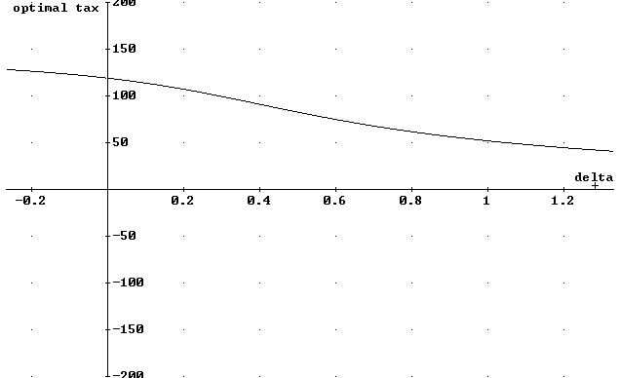

Figure 1

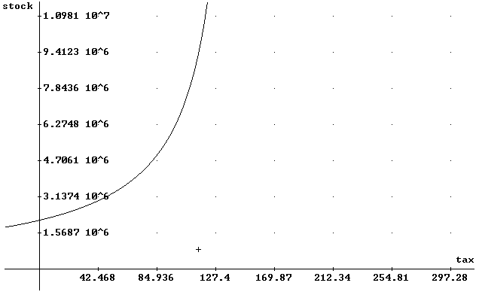

Figure 2

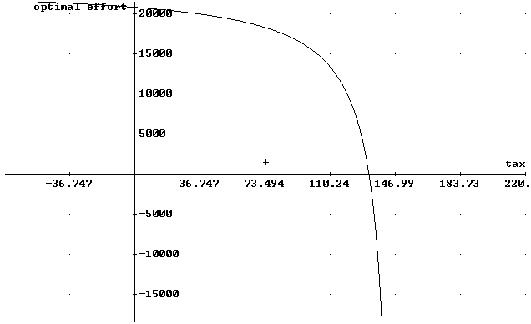

Figure 3
8. References

Clark, C.W. (1990), Mathematical Bioeconomics, John Wiley and Sons, New York.

García Ordaz, F., García del Hoyo, J. (1998), Un modelo bioeconómico para la pesquería de chamelea gallina de la Región Suratlántica española, Estudios Agrosociales y Pesqueros, 184, 183-211.

Pradhan, T., Chaudhuri, K.S. (1999), A dynamic reaction model of a two especies fishery with taxation as a control instrument:a capital theoretic analysis, Ecological Modelling 121, 1-16.

Verhulst, P.F. (1938), Notice sur la loi que la population suit dans son accroissement. Correspondance Mathématique et Physique 10, 113-121.

Verhulst, P.F. (1838)
Clark, C.W. (1990), p. 111, Pradhan, T. Et al (1999)
Note that if $τ=\bar{τ}$, P₃= P₂ and no interior steady state exists.
P₃ is a solution of system (10). Hence, r(1-x*/K)-qz* = 0 and -γ+ αβ(-c+ q(p-τ)x*)= 0
Note that τ_{max} must be less that $\bar{τ}$in order P₃ to exist.

