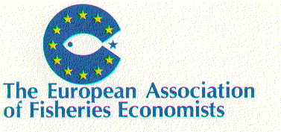
EXPRESSION OF INTEREST

in Membership of
EAFE Economics Working Groups

Return to the EAFE Secretariat: elsebeth@foi.dk and copy to relevant chairperson

Address for Correspondence
Name
Organisation
Street and Number
Village/District
Town/City
Postcode
Country

Telephone (Full International Dialing)
Telefax (Full International Dialing)
E-Mail Address

Will you require to be paid a day rate to attend meetings? | Yes [ ] | No [ ]

EAFE Commitments of Interest (Mark "X")
Academic networks |  | Baltic Sea RAC |  | MARIFISH
North Sea RAC |  | EFARO

Specialisations; please list
(eg Fishery Management, Economic Models,
Demand and Supply,
Fish Processing, Econometrics, Capacity,
Aquaculture)

